

SENIOR PROJECT

Elif Necla BEKTAŞ – 21030411025
Busenur YILDIRIM – 21030411012
Kevser ÇALIŞKAN – 21030411032
Hasan Buğra ZENGİN - 21030411049
Fakı AVCU – 21030411047

ANKARA YILDIRIM BEYAZIT UNIVERSITY
BUSINESS FACULTY
SUBMITTED TO:
Dr. Musab Talha Akpınar

Content

1. Introduction

1.1. Team Structure and Responsibilities (RACI Matrix)

1.2. Team

2. Project Background and Importance

3. Literature Review

3.1. Social Media and Its Role in Business

3.2. Brand Image and Brand Reputation

3.3. Customer Sentiment and Online Opinions

3.4. Sentiment Analaysis in Academic Studies

3.5. Social Media Analaysis and Brand Management

3.6. Social Media and Brand Analaysis in the E-Commerce Sector

3.7. Social Media and Brand Analaysis in the Banking Sector

3.8. Social Media and Brand Analaysis in the Aviation Sector

3.9. Social Media and Brand Analaysis in theTelecommunications Sector

3.10. Summary of the Literature Review

4. Scope of Projects

4.1. Scope of the Project

4.2. Out of Scope of the Project

4.3. Project Objectives

4.4. Assumptions and Constraints

4.5. Project Deliverables

5. Project Planning

5.1. Work Breakdown Structure

5.2. Project Timeline (Gantt Chart)

5.3. Risk Assessment

5.4. Stakeholder Assessment

6. Social Media & Brand Environment

6.1. The role of Social Media in Brand Communication

6.2. Social Media as a Source of Customer Feedback

6.3. Brand Environment of Selected Companies

6.4. Social Media Environment of Trendyol

6.5. Social Media Environment of Hepsiburada

6.6. Social Media Environment of Garanti Bank

6.7. Social Media Environment of Trendyol Turkish Airlines

6.8. Social Media Environment of Turkcell

6.9. Importance of Social Media Environmment for Analaysis

7. System Design

7.1. Overview of the System Design

7.2. System Objectives

7.3. System Users and User Roles

7.4. Data Sources and Input Layer

7.5. Data Processing Layer

7.6. Sentiment Analaysis Module

7.7. Brand Comparison and Risk Evaluation

7.8. Output Layer and Visualzation

7.9. System Design as a Foundation for Diagrams

7.10. Summary of the System Design

8. Analaysis Strategy

8.1. Purpose of the Analaysis Strategy

8.2. Data collection Strategy

8.3. Data Scope and Time Period

8.4. Data Cleaning and Preparation

8.5. Sentiment Analaysis Approach

8.6. Application of Sentiment Analaysis

8.7. Brand-Based Sentiment Comparison

8.8. Platform-Based Sentiment Analaysis

8.9. Time-Based Sentiment Analaysis

8.10. Reliability and Validity of the Analaysis

8.11. Summary of the Analaysis Strategy

9. Example Findings and Graph Analaysis

9.1. Purpose of the Findings Section

9.2. Overall Sentiment Distribution Across Brands

9.3. Brand-Based Sentiment Comparison

9.4. Platform-Based Sentiment Analaysis

9.5. Time-Based Sentiment Trends

9.6. Brand Risk Evaluation Based on Sentiment Results

9.7. Interpretation of Findings for Management

9.8. Limitations of the Findings

9.9. Contribution of the Findings to the Project

9.10. Summary of Example Findings

10. Ethical and Sustainability Considerations

11. Use Case

11.1. Use Case

11.2. System Architecture Diagram

11.3. Diagrams

11.3.1. Context Diagram

11.3.2. Logical Data Flow Diagram – Level 0

11.3.3. Logical Data Flow Diagram – Level 1

11.3.4. Logical Data Flow Diagram – Level 2

11.3.5. Logical Data Flow Diagram – Level 3

11.3.6. Physical Data Flow Diagram – Level 0

11.3.7. Physical Data Flow Diagram – Level 1

11.3.8. Physical Data Flow Diagram – Level 2

11.3.9. Physical Data Flow Diagram – Level 3

11.4. Entity Relationship Diagram

12. Conclusiın and Recommendations

12.1. Conclusion of the Project

12.2. Evaluation of the Project Objectives

12.3. Managerial Implications

12.4. Recommendations for Brands

12.5. Limitations of the Project

12.6. Suggestion for Future Studies

12.7. Final Remarks

13. Referances

1. INTRODUCTION
Social media has become one of the most powerful communication tools in the modern business world. Today, millions of people use social media platforms such as Twitter (X), Instagram, and TikTok to share their opinions, experiences, and emotions. Because of this wide usage, social media is no longer only a personal communication tool, but also an important business environment for brands.
Brands use social media to promote their products and services, communicate with customers, and build a strong brand image. Customers, on the other hand, use social media to express satisfaction, dissatisfaction, complaints, and expectations. This two-way communication creates a large amount of data every day. These data include comments, likes, shares, and posts related to brands.
In highly competitive markets, understanding customer opinions is very important. Traditional market research methods such as surveys and interviews are still useful, but they are often time-consuming and costly. Social media analysis provides faster and more dynamic insights because customers share their opinions voluntarily and continuously. For this reason, social media data has become a valuable source for brand analysis.
Brand reputation is one of the most critical factors for business success. A strong and positive brand reputation increases customer trust and loyalty. However, negative comments and complaints can quickly spread on social media and damage brand image. If these risks are not detected early, they can lead to serious reputation problems. Therefore, brands need effective systems to monitor and analyze social media data.
This senior project focuses on social media and brand analysis by using sentiment analysis techniques. Sentiment analysis is a method used to identify emotions and opinions in text data. In this project, customer comments are classified as positive, neutral, or negative. This classification helps brands understand general customer sentiment and detect possible risks.
The project analyzes five major brands from different sectors: Trendyol, Hepsiburada, Garanti Bankası, Turkish Airlines, and Turkcell. These brands were selected because they are well-known in Turkey, have a large customer base, and actively use social media platforms. Each brand operates in a different industry, which allows a comparative analysis across sectors.
Trendyol and Hepsiburada are leading companies in the e-commerce sector. Customers frequently share their shopping experiences, delivery problems, and satisfaction levels on social media. Garanti Bankası represents the banking sector, where customer trust and service quality are very important. Turkish Airlines operates in the aviation sector, where customer experiences such as flight delays and service quality are often discussed online. Turkcell represents the telecommunications sector, where service performance and customer support are key topics on social media.
The main purpose of this project is to analyze social media data related to these brands and provide meaningful insights for brand management. By using sentiment analysis, the project aims to help managers understand customer behavior, improve communication strategies, and reduce reputation risks. The results of this project can support strategic decision-making processes in organizations.
  - Team Structure and Responsibilities (RACI Matrix)
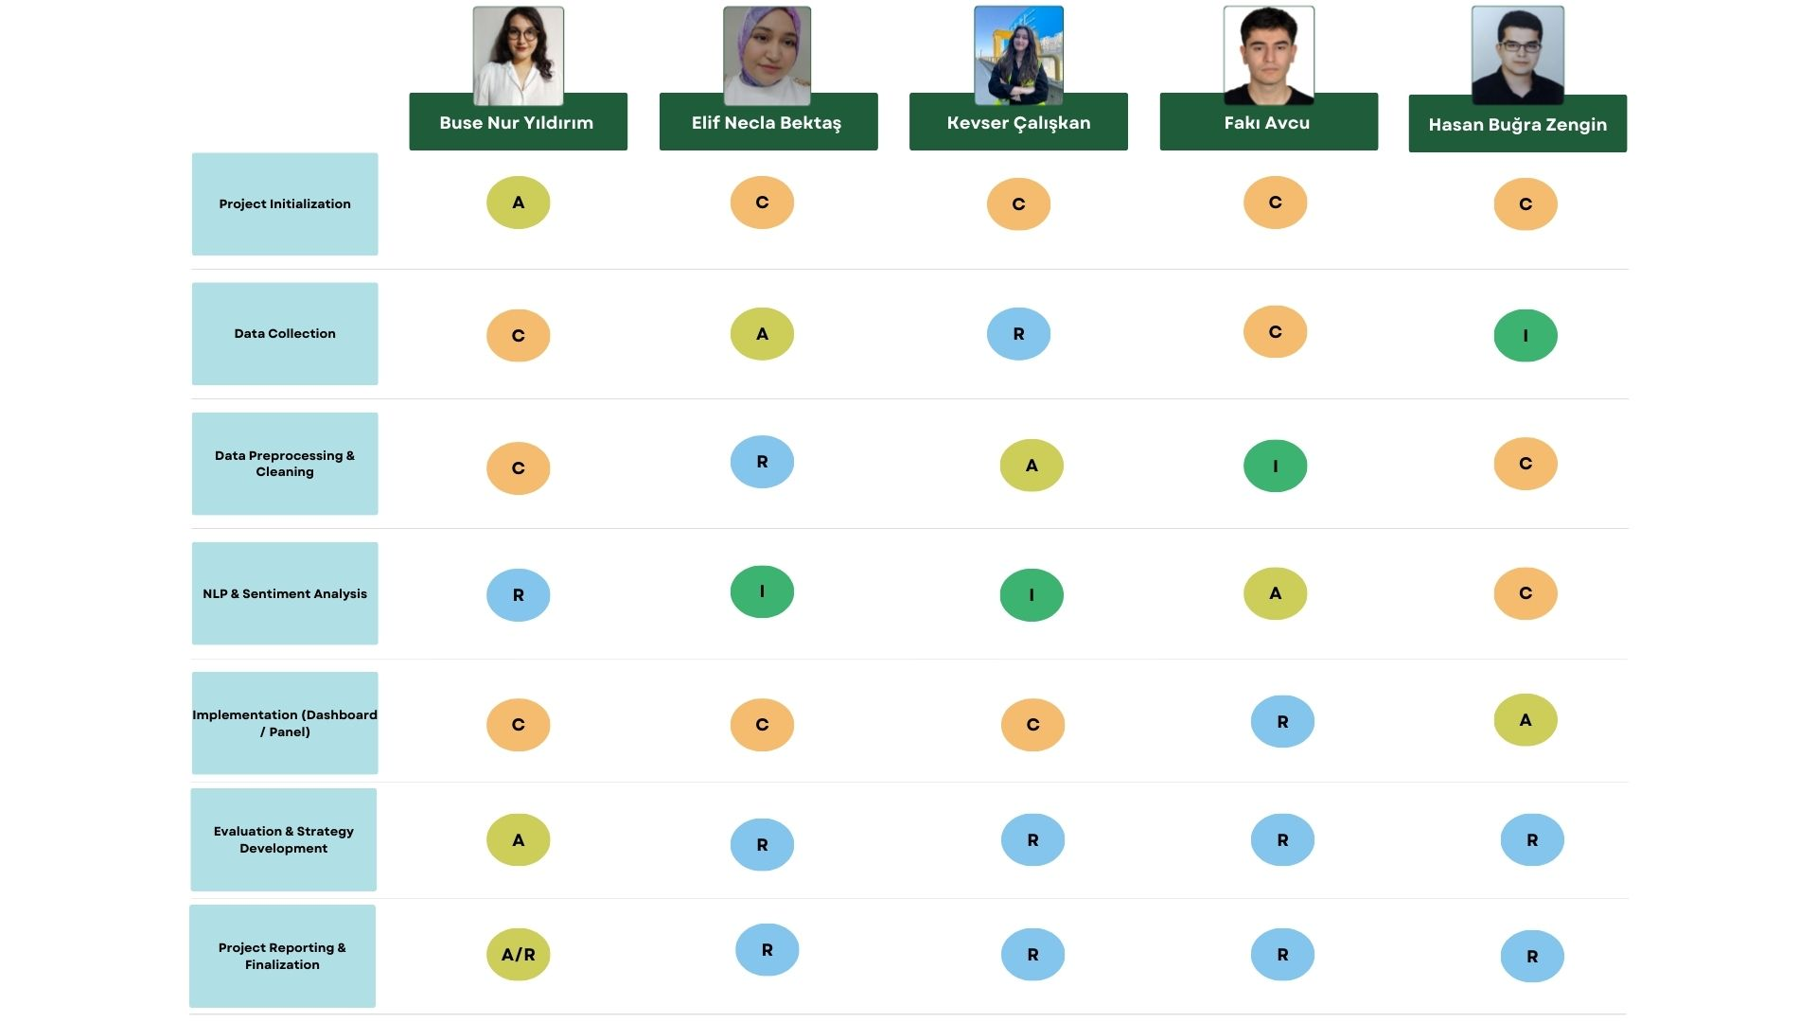

  - Team

2. PROJECT BACKGROUND AND IMPORTANCE
In recent years, the rapid growth of digital technologies has changed the way businesses communicate with customers. One of the most important results of this change is the increasing role of social media in daily life. Social media platforms are no longer only used for entertainment or personal communication. They have become powerful tools for marketing, customer communication, and brand management.
Brands use social media to introduce new products, announce campaigns, and create brand awareness. At the same time, customers actively use these platforms to share their opinions, complaints, and experiences. This situation creates a very dynamic and fast communication environment. As a result, brands must closely follow what customers say about them on social media.
The importance of social media analysis has increased because customer opinions can spread very quickly. A single negative comment can reach thousands of people in a short time. If brands do not notice these comments early, they may face serious reputation problems. For this reason, monitoring social media data is not optional anymore, but necessary for modern businesses.
Another important background factor of this project is the increase in data volume. Every day, millions of posts and comments are shared on social media platforms. This large amount of data cannot be analyzed manually. Therefore, automated analysis methods such as sentiment analysis are needed. These methods help brands process large datasets and extract meaningful information.
This project is important because it combines social media data with analytical methods. By using sentiment analysis, the project transforms unstructured text data into structured and understandable results. Positive, neutral, and negative sentiments are identified, and brand perception is measured in a simple way.
From a management perspective, social media brand analysis supports better decision-making. Managers can see which topics create negative reactions and which campaigns receive positive feedback. This information helps brands improve their strategies and customer communication.
In addition, this project is important for academic purposes. It shows how information systems and data analysis techniques can be applied to real-life business problems. The project also contributes to the understanding of social media’s role in brand reputation management.

3. LITERATURE REVIEW

3.1 Social Media and Its Role in Business
Social media is widely discussed in academic studies because of its strong impact on business and marketing activities. Many researchers state that social media platforms allow brands to communicate directly with customers. This direct communication helps brands understand customer needs, opinions, and expectations in a faster way.
According to previous studies, social media has changed traditional marketing methods. In the past, brands mostly used one-way communication, such as television or newspaper advertisements. Today, social media provides two-way communication. Customers can comment, share, and react to brand content. This interaction creates a strong relationship between brands and customers.
Researchers also emphasize that social media is an important source of information. Customers trust online reviews and comments more than traditional advertisements. Positive comments increase brand credibility, while negative comments can reduce customer trust. For this reason, social media plays a key role in shaping brand image.
Many academic studies show that brands that actively manage their social media accounts have stronger customer engagement. Engagement includes likes, shares, comments, and mentions. High engagement levels usually indicate positive customer interest and satisfaction.

3.2 Brand Image and Brand Reputation
Brand image refers to how customers perceive a brand in their minds. It is formed by customer experiences, marketing messages, and social interactions. Researchers explain that brand image is not only created by the company, but also by customer opinions shared in public environments such as social media.
Brand reputation is closely related to brand image but focuses more on long-term perception. Academic studies suggest that a strong brand reputation provides competitive advantage. Customers are more likely to choose brands with a positive reputation.
Social media has a strong influence on brand reputation because information spreads very quickly. A single negative experience can be shared by many users in a short time. For this reason, reputation management has become more complex in the digital age.
Previous research shows that monitoring customer comments on social media helps brands protect their reputation. Early detection of negative sentiment allows companies to respond quickly and reduce possible damage.

3.3 Customer Sentiment and Online Opinions
Customer sentiment means the emotional tone of customer opinions. In academic literature, customer sentiment is often divided into three categories: positive, neutral, and negative. These categories help researchers analyze large amounts of text data in a simple way.
Many studies explain that customer sentiment reflects customer satisfaction levels. Positive sentiment usually shows satisfaction and loyalty, while negative sentiment indicates dissatisfaction and complaints. Neutral sentiment often includes informative or unclear opinions.
Online opinions shared on social media platforms are valuable because they are created voluntarily by customers. Researchers state that these opinions provide more honest feedback compared to traditional surveys.
Several academic studies focus on analyzing customer sentiment to predict customer behavior. For example, an increase in negative sentiment may indicate potential customer churn or reputation risk.

3.4 Sentiment Analysis in Academic Studies
Sentiment analysis is a popular method used in social media research. It is a text analysis technique that identifies emotions and opinions in written content. Researchers use sentiment analysis to analyze customer comments, reviews, and posts.
Academic studies show that sentiment analysis is effective for analyzing large datasets. Manual analysis is not practical when thousands of comments are involved. Automated sentiment analysis methods help researchers save time and reduce human bias.
Most studies use simple sentiment classification models that categorize text as positive, neutral, or negative. This approach is suitable for business and management studies because it produces clear and understandable results.
Researchers also note that sentiment analysis supports decision-making processes. Managers can use sentiment results to evaluate campaigns, services, and customer reactions.

3.5 Social Media Analysis and Brand Management
Many academic studies highlight the importance of social media analysis for brand management. Social media analysis helps brands understand how customers react to products, services, and campaigns.
Researchers explain that social media analytics tools provide valuable insights for managers. These tools help identify trends, customer preferences, and potential problems. As a result, brands can improve their strategies and communication plans.
In the literature, social media analysis is often linked to strategic management. By analyzing customer sentiment, brands can adjust their actions and respond to customer needs more effectively.

3.6 Social Media and Brand Analysis in the E-Commerce Sector
The e-commerce sector is one of the most active sectors on social media. Many academic studies focus on online shopping platforms because customers frequently share their shopping experiences online. Researchers state that social media plays an important role in shaping customer trust in e-commerce brands.
Studies show that customers often use social media to comment on delivery speed, product quality, and customer service. Positive comments increase brand credibility, while negative comments can strongly affect purchase decisions. For this reason, e-commerce companies closely monitor social media platforms.
In the literature, sentiment analysis is widely used to analyze customer opinions about e-commerce brands. Researchers explain that sentiment analysis helps identify common problems such as late delivery, damaged products, or poor customer support. At the same time, positive feedback helps brands understand their strengths.
Trendyol and Hepsiburada are often discussed in academic and industry-based studies because they are leading e-commerce platforms in Turkey. Studies highlight that these platforms receive high interaction on social media due to their large customer base. Therefore, analyzing customer sentiment for these brands provides valuable insights for the e-commerce sector.

3.7 Social Media and Brand Analysis in the Banking Sector
The banking sector is another important area discussed in social media and brand analysis studies. Researchers emphasize that trust is the most important factor in banking services. Because of this, customer opinions shared on social media are very sensitive and valuable.
Academic studies show that customers often use social media to express complaints about banking services. Topics such as mobile banking problems, customer service quality, and transaction issues are frequently mentioned. Negative comments can quickly damage a bank’s reputation if they are not managed properly.
Sentiment analysis is commonly used in banking studies to monitor customer satisfaction and dissatisfaction levels. Researchers explain that early detection of negative sentiment helps banks respond quickly and reduce reputation risks.
Garanti Bankası is often mentioned in studies related to digital banking and customer experience. Its active use of social media makes it a suitable example for social media brand analysis. Literature suggests that banks that actively respond to customer comments can improve their brand image.

3.8 Social Media and Brand Analysis in the Aviation Sector
The aviation sector is highly sensitive to customer experiences. Academic studies highlight that passengers often share their flight experiences on social media platforms. Issues such as flight delays, baggage problems, and service quality are common topics in online discussions.
Researchers explain that negative experiences in aviation spread very quickly on social media. A single negative post can reach many users in a short time. For this reason, reputation management is very important for airline companies.
Sentiment analysis is frequently used in aviation studies to measure passenger satisfaction. Studies show that analyzing social media comments helps airlines identify service problems and improve customer experience.
Turkish Airlines is widely discussed in the literature because it operates internationally and has a large customer base. Researchers state that social media analysis helps the company understand passenger expectations and manage its global brand image.

3.9 Social Media and Brand Analysis in the Telecommunications Sector
The telecommunications sector is closely related to service quality and customer support. Academic studies show that customers often use social media to share opinions about internet speed, network coverage, and pricing.
Researchers emphasize that customer complaints are very common in this sector. Because services are used daily, even small problems can cause negative customer reactions. Social media becomes an important platform for customers to express dissatisfaction.
Sentiment analysis is widely used in telecommunications studies to analyze customer feedback. Researchers explain that analyzing negative sentiment helps companies identify service problems and improve customer satisfaction.
Turkcell is frequently mentioned in studies related to digital services and customer communication. Its strong presence on social media makes it an important case for brand analysis. Literature suggests that active social media management can reduce customer complaints and improve brand perception.

3.10 Summary of the Literature Review
In summary, the academic literature clearly shows that social media plays a critical role in brand management across different sectors. Studies emphasize that customer opinions shared on social media strongly affect brand image and reputation.
The literature also highlights the importance of sentiment analysis as an effective method for analyzing social media data. By classifying customer opinions as positive, neutral, or negative, researchers and managers can better understand customer sentiment.
Sector-based studies show that although industries differ, social media analysis is important for all sectors. E-commerce, banking, aviation, and telecommunications companies all benefit from monitoring and analyzing customer opinions on social media platforms.
This literature review provides a strong academic foundation for the current project. The findings from previous studies support the use of social media sentiment analysis for brand evaluation and reputation management.

4. SCOPE OF PROJECTS

4.1. Scope of the Project
The scope of this project defines the boundaries, objectives, and limitations of the Social Media Brand Analysis System. The project focuses on analyzing customer opinions shared on social media platforms in order to understand brand perception and reputation.
Within the scope of this project, social media data is collected from publicly available platforms. The analysis focuses on selected major brands operating in different sectors, including e-commerce, banking, aviation, and telecommunications. The selected brands represent well-known companies with active social media presence.
The project includes data collection, data preprocessing, sentiment analysis, and result visualization. Social media comments are analyzed to identify customer sentiment and classify opinions as positive, neutral, or negative. This classification helps evaluate customer satisfaction and brand perception.
The scope also includes brand-based, platform-based, and time-based sentiment analysis. These analyses allow comparison between brands, understanding of platform differences, and observation of sentiment changes over time.
System design and implementation are also included in the project scope. A basic analytical system is designed to process social media data and present results in a clear and understandable format using graphical representations.
Ethical and sustainability considerations are included within the scope of the project. Only publicly available data is used, and no personal or sensitive information is collected. The project aligns with sustainable brand management principles and the United Nations Sustainable Development Goals.
The project scope does not include real-time data processing or advanced machine learning model development. The analysis is based on representative data and focuses on academic evaluation rather than commercial implementation.
In conclusion, the scope of this project covers social media data analysis for brand evaluation within defined ethical, technical, and academic boundaries. The project aims to provide meaningful insights for brand management and future research.

4.2. Out of Scope of the Project
This section explains the elements that are not included within the scope of this project. Defining what is out of scope helps clarify the project boundaries and prevents unrealistic expectations.
Real-time social media data processing is not included in this project. The analysis is based on representative datasets collected during a specific period. Continuous live monitoring is outside the project scope.
Advanced machine learning model development is also not included. Although machine learning is discussed as a future improvement, the project focuses on rule-based and classification-oriented sentiment analysis for academic purposes.
The project does not include commercial deployment or integration with company internal systems. The system is designed as an academic prototype rather than a fully operational business system.
In addition, private social media data and restricted platforms are excluded. Only publicly available content is analyzed in accordance with ethical standards.

4.3. Project Objectives
The main objective of this project is to analyze social media data in order to understand brand perception and customer sentiment. The project aims to support brand management and reputation evaluation through systematic analysis.
Another objective is to design a simple and structured analytical system that processes social media data and presents results in a clear and understandable format.
The project also aims to compare customer sentiment across different brands, social media platforms, and time periods. This comparison helps identify strengths, weaknesses, and potential risks for brands.
In addition, the project aims to support sustainable brand management by aligning analysis outcomes with ethical principles and the United Nations Sustainable Development Goals.

4.4. Assumptions and Constraints
This project is developed based on several assumptions. It is assumed that social media comments reflect real customer opinions and experiences. It is also assumed that publicly available data provides sufficient insight for academic analysis.
Another assumption is that the selected brands are representative of their respective sectors. The analysis results are interpreted within this assumption.
The project has certain constraints. Time limitations restrict the size of the dataset and the duration of analysis. Technical limitations also affect the complexity of analytical methods used.
Language differences and informal social media expressions may limit sentiment classification accuracy. These constraints are acknowledged to ensure transparency.

4.5. Project Deliverables
The project delivers a structured academic report that presents the research framework, analysis process, and findings in detail.
Another key deliverable is the system design that illustrates how social media data is collected, processed, and analyzed. System diagrams and process flows are included as part of the deliverables.
The project also delivers sentiment analysis results in graphical and tabular formats. These outputs support brand comparison and evaluation.
In addition, strategic recommendations based on analysis findings are provided to support brand management and future research.

5. PROJECT PLANNING
Project planning is an important part of this study because it defines how the project is organized and developed over time. This section explains the main activities, task structure, timeline, and planning approach used during the project.
Although this project is not a full project management study, basic project planning tools are used to support systematic development. These tools help ensure that the project progresses in a structured and controlled manner.
The project planning process focuses on defining tasks, organizing activities, and managing time effectively. It also helps clarify the relationship between different project stages, such as data collection, analysis, system design, and reporting.
This section includes the Work Breakdown Structure (WBS) and the Gantt chart. The Work Breakdown Structure shows how the project is divided into smaller and manageable tasks. The Gantt chart presents the project timeline and illustrates the duration and sequence of these tasks.
In addition, project planning supports risk awareness and stakeholder understanding. By identifying possible risks and key stakeholders early, the project reduces uncertainty and improves coordination.
Overall, the project planning approach used in this study ensures that the project is completed within defined time limits and academic requirements. It also supports transparency and clarity throughout the project development process.
5.1. Work Breakdown Structure
The Work Breakdown Structure (WBS) is used to divide the project into smaller and manageable tasks. The WBS presents the main project phases, including planning, data collection, analysis, system design, and reporting. This structure helps organize project activities and improve time management.
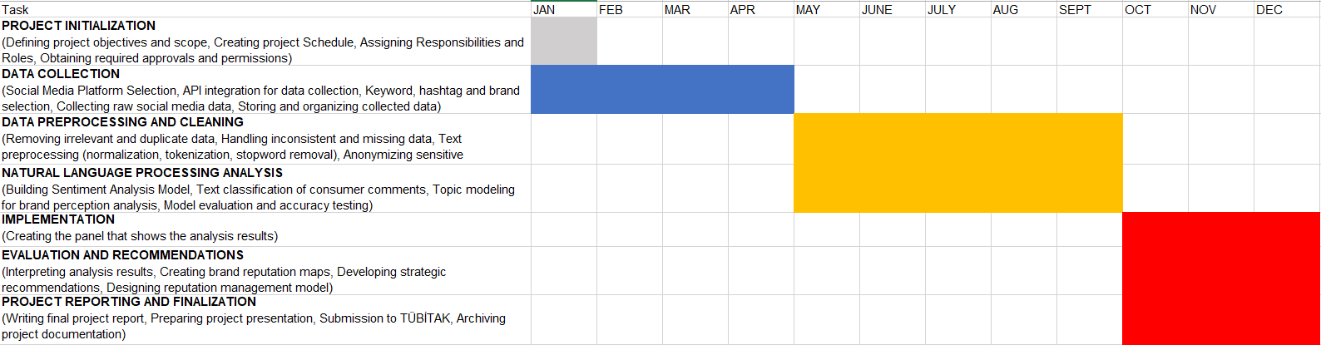

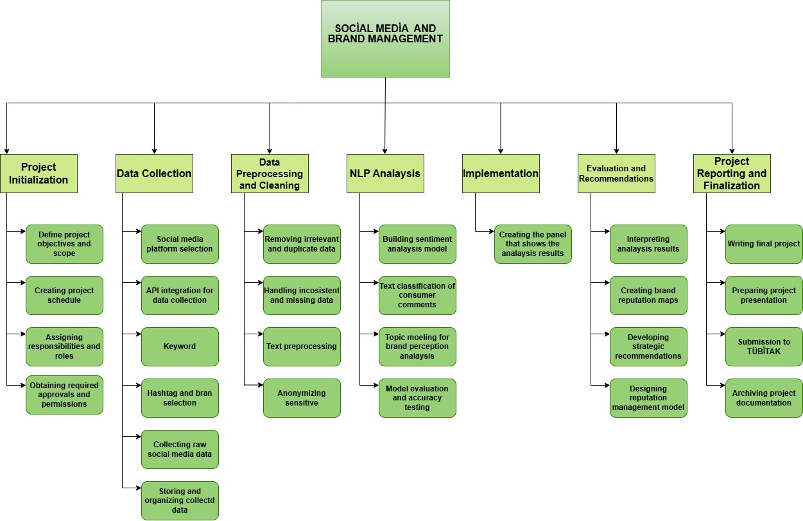

5.2. Project Timeline (Gantt Chart)
The Project illustrates the 28-week project timeline prepared using a status-based Gantt chart. Completed, ongoing, and delayed phases are clearly distinguished to reflect the progress of the research. This timeline demonstrates structured planning, task dependencies, and effective time management throughout the graduation project.
Some phases are marked as delayed due to their dependency on data collection and analysis. However, parallel task execution ensures that the final submission deadline is maintained.
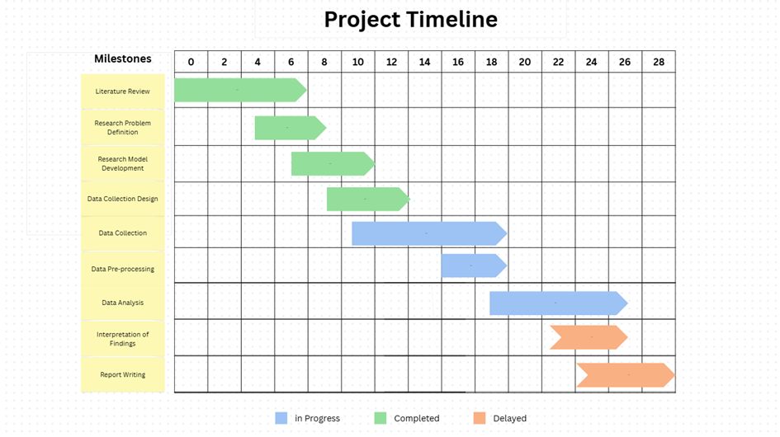

 | Work Package | Description | Output
1 | Literature Review | Review of academic studies on social media analytics, NLP, sentiment analysis, and brand reputation | Literature synthesis & conceptual framework
2 | Research Problem Definition | Clarification of research objectives, questions, and hypotheses | Research questions & hypotheses
3 | Research Model Development | Identification of variables and construction of the conceptual research model | Research model diagram
4 | Data Collection Design | Definition of data sources, platforms, and time period | Data collection protocol
5 | Data Collection | Collection of social media data from selected platforms | Raw dataset
6 | Data Pre-processing | Cleaning, normalization, and preparation of data for analysis | Clean and structured dataset
7 | Data Analysis | NLP-based sentiment analysis and statistical evaluation | Analysis results
8 | Interpretation of Findings | Evaluation of results in line with research questions | Findings section
9 | Report Writing | Writing of findings, discussion, conclusions, and recommendations | Graduation project report
10 | Final Review and Submission | Formatting, proofreading, and academic compliance checks | Final submitted report

5.3.Risk Assessment
This study focuses on social media analytics for brand management with the aim of developing effective reputation management strategies. Throughout the 28-week project timeline, several potential risks were identified, particularly those related to data collection, analytical processes, and the interpretation of brand-related insights.
One significant risk concerns access to relevant social media data. Limitations imposed by platform APIs, data privacy regulations, or changes in platform policies may restrict the volume or type of data that can be collected. Such constraints may delay the data collection phase and affect the representativeness of brand-related discussions.
Another important risk involves data quality and noise. Social media data often contain spam, irrelevant content, sarcasm, and ambiguous language, which can negatively impact sentiment analysis results. Addressing these issues may increase the time required for data pre-processing and introduce delays in subsequent analytical stages.
A further risk is related to sentiment misclassification and model performance. Automated sentiment analysis tools may struggle to accurately interpret brand mentions, especially in cases involving irony, mixed emotions, or context-dependent meanings. This may reduce the reliability of analytical outcomes and require additional validation or model refinement.
Additionally, there is a risk associated with rapid changes in online brand perception. Sudden events, viral content, or crises may cause abrupt shifts in public sentiment, making it difficult to draw stable conclusions from historical data. This may complicate the interpretation of findings and the formulation of long-term reputation management strategies.
To mitigate these risks, multiple preventive measures were integrated into the project plan. Data were collected from diverse sources to increase representativeness, and filtering techniques were applied to reduce noise. Model performance was evaluated through validation steps, and qualitative interpretation was combined with quantitative results to strengthen analytical reliability. Buffer periods were also allocated in the interpretation and report writing phases to accommodate potential delays.
Overall, while certain risks may affect the duration of specific project phases, they are considered manageable and do not pose a significant threat to the successful completion of the study or the development of actionable brand reputation management strategies.

No | Risk Description | Risk Source | Probability | Impact | Risk Level | Preventive Action | Contingency Plan (Plan B)
R1 | Insufficient academic literature | Limited access to recent or relevant academic sources | Medium | Medium | Medium | Use of multiple academic databases | Focus on open-access journals
R2 | Delay in data collection | API restrictions or platform limitations | Medium | High | High | Early initiation of data collection | Narrowing the data collection period
R3 | Low data quality | Presence of spam, duplicate, or irrelevant content | Medium | Medium | Medium | Strict data cleaning and filtering rules | Exclusion of low-quality data
R4 | Limited reliability of analysis results | Limitations of NLP sentiment analysis methods | Low | High | Medium | Use of validated NLP techniques from literature | Application of alternative analysis methods
R5 | Deviation from project schedule | Academic workload or personal constraints | Medium | High | High | Weekly progress monitoring | Scope reduction while maintaining core objectives
R6 | Delay in report writing | Postponing the writing phase until late stages | Medium | Medium | Medium | Parallel writing during analysis phase | Section-by-section writing approach

5.4. Stakeholder Assessment
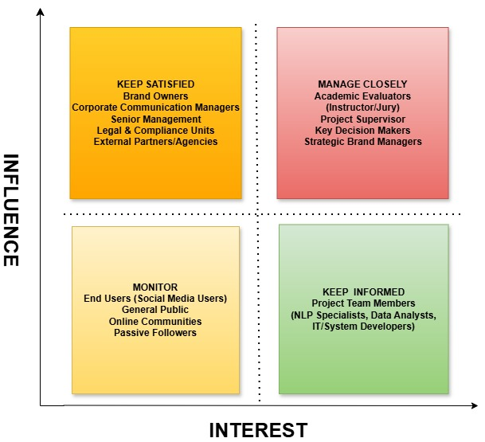

6. SOCIAL MEDIA & BRAND ENVIRONMENT

6.1 The Role of Social Media in Brand Communication
Social media has become an essential part of brand communication in the digital age. Today, brands use social media platforms not only to promote products, but also to communicate directly with customers. Platforms such as Twitter (X), Instagram, Facebook, and TikTok provide brands with an effective way to reach large audiences.
One of the most important roles of social media in brand communication is interaction. Unlike traditional media, social media allows two-way communication. Customers can comment on brand posts, ask questions, and share their opinions instantly. Brands can also respond to these comments and messages in a short time. This fast interaction helps brands understand customer needs, expectations, and problems more clearly.
Social media communication also helps build stronger relationships between brands and customers. When customers feel that a brand listens to them and responds to their feedback, they feel more valued. This sense of closeness increases customer trust and satisfaction. As a result, customers are more likely to develop a positive attitude toward the brand.
Another important role of social media is creating and maintaining brand identity. Brands use social media to present their values, mission, and vision. Through regular posts, videos, and campaigns, brands can create a consistent brand image. Consistency in communication helps customers recognize and remember the brand more easily.
Social media platforms also allow brands to use visual content effectively. Images, videos, and short clips attract more attention than text-based communication. Visual content helps brands express emotions, stories, and messages in a simple and engaging way. This strengthens emotional connections between brands and customers.
In addition, social media supports transparency in brand communication. Customers can see how brands respond to complaints and negative comments. Brands that communicate openly and honestly are perceived as more trustworthy. On the other hand, brands that ignore customer feedback may damage their reputation.
Social media also plays an important role in crisis communication. When a problem occurs, brands can use social media to inform customers quickly. Fast and clear communication during crisis situations helps reduce negative impact and protect brand reputation.
Furthermore, social media enables brands to follow trends and adapt their communication strategies. By analyzing customer comments and reactions, brands can improve their messages and campaigns. This flexibility makes social media a powerful communication tool.
In conclusion, social media plays a critical role in brand communication by enabling fast interaction, building relationships, creating brand identity, and supporting transparency. Effective use of social media helps brands improve customer satisfaction and strengthen long-term brand loyalty.

6.2 Social Media as a Source of Customer Feedback
Customer feedback is one of the most valuable sources of information for brands. Feedback helps brands understand how customers feel about products, services, and overall brand performance. In the digital age, social media has become one of the most important channels for collecting customer feedback.
Social media platforms allow customers to share their experiences freely and openly. Customers write comments, post reviews, ask questions, and express complaints without any restrictions. This feedback is shared in real time, which means brands can receive information immediately after a customer experience occurs.
One important advantage of social media feedback is its honesty. Academic studies explain that social media feedback is often more natural and realistic than traditional feedback methods. Customers do not need to fill out surveys or participate in structured interviews. Instead, they share their opinions voluntarily. Because of this, social media data reflects real customer sentiment more accurately.
Social media feedback includes both positive and negative experiences. Positive feedback helps brands understand what they are doing well. Customers often share satisfaction related to product quality, fast delivery, or good customer service. This information helps brands strengthen successful strategies.
Negative feedback is also very important for brands. Customers use social media to complain about problems such as delays, poor service, or communication issues. Although negative feedback may seem harmful, it provides valuable insights. By analyzing complaints, brands can identify weaknesses and improve their services.
In addition, social media allows customers to give suggestions and ideas. Customers may recommend improvements or new features. This type of feedback supports innovation and customer-oriented development.
However, the large volume of social media data creates challenges. Thousands of comments, messages, and posts are shared every day. Manual analysis of this data is time-consuming and not practical. It is difficult for brands to read and evaluate every comment individually.
Because of this challenge, analytical methods are needed. Sentiment analysis is one of the most commonly used techniques to analyze social media feedback. It helps classify customer comments as positive, negative, or neutral. This classification makes large data sets easier to understand.
By using sentiment analysis, brands can identify general trends in customer feedback. They can monitor changes in customer satisfaction over time and detect potential problems early. This helps brands respond faster and improve decision-making.
In conclusion, social media is a powerful source of customer feedback. It provides real-time, honest, and diverse opinions. When supported by analytical methods, social media feedback becomes a valuable tool for improving brand communication and performance.

6.3 Brand Environment of Selected Companies
This project focuses on five major brands operating in different sectors: Trendyol, Hepsiburada, Garanti Bankası, Turkish Airlines, and Turkcell. These brands were selected because they are well-known in Turkey and have a strong presence on social media platforms. They actively use social media to communicate with customers and manage their brand image.
Trendyol and Hepsiburada operate in the e-commerce sector. These brands interact with customers mainly about product quality, delivery speed, return processes, and customer service. Social media is an important channel for customers to share shopping experiences. Positive comments usually relate to fast delivery and discounts, while negative comments often focus on delays or order problems.
Garanti Bankası represents the banking sector. In this sector, customer expectations are very high, especially regarding trust, security, and service quality. Customers frequently use social media to ask questions, report problems, or express dissatisfaction with banking services. Therefore, social media communication plays a critical role in maintaining customer trust.
Turkish Airlines operates in the aviation sector, where service quality and safety are very important. Customers often share experiences related to flight delays, baggage handling, and customer support. Because aviation services directly affect travel experiences, social media feedback can be very emotional and influential.
Turkcell represents the telecommunications sector. Customers frequently discuss network quality, internet speed, pricing, and customer service on social media. Because telecommunication services are used daily, customer feedback is continuous and highly visible.
Although these brands operate in different industries, they face similar challenges on social media. Customer expectations are high across all sectors. Customers expect fast responses, clear information, and effective problem-solving. Negative experiences can quickly turn into public complaints that spread widely.
Another common challenge is reputation management. A single negative post can attract attention and influence public opinion. Therefore, brands must monitor social media platforms carefully and respond to customer feedback quickly.
Understanding the social media environment of each brand is essential for analysis. Each sector has unique customer expectations, but common patterns such as complaint behavior and sentiment trends can be observed. This understanding provides a strong foundation for comparative analysis in this project.
In conclusion, the selected brands operate in different sectors but share similar social media dynamics. Analyzing their social media environment helps evaluate brand perception and customer sentiment more effectively.

6.4 Social Media Environment of Trendyol
Trendyol is one of the largest and most popular e-commerce platforms in Turkey. It has millions of active users and a very strong presence on social media platforms. Trendyol uses social media actively to promote campaigns, announce discounts, and communicate with customers.
Customers frequently share their shopping experiences related to Trendyol on social media. These experiences include opinions about product quality, delivery speed, return processes, and customer service. Because online shopping is closely related to customer satisfaction, social media becomes an important space for feedback.
On platforms such as Twitter (X) and Instagram, Trendyol receives a high number of comments every day. Many of these comments are related to order status and delivery time. Customers often ask questions about where their orders are and when they will arrive. This shows that delivery performance is a critical issue for customer satisfaction.
Positive comments usually focus on wide product variety, discounts, and affordable prices. Campaigns and special sales periods often create positive sentiment. However, negative comments are also common. These comments usually mention delivery delays, damaged products, or problems with the return process.
Because of this highly active and dynamic social media environment, Trendyol is a very suitable brand for sentiment analysis. Analyzing customer comments helps identify repeating problems and customer expectations. This analysis can support service improvement and communication strategies.

6.5 Social Media Environment of Hepsiburada
Hepsiburada is another leading e-commerce company in Turkey. Similar to Trendyol, it has a large customer base and strong social media activity. Customers actively use social media to share opinions about their shopping experiences.
Social media platforms are used by customers to ask questions, report problems, and express satisfaction. Comments related to delivery speed, pricing, customer support, and refund processes are very common. These topics show what customers value most in e-commerce services.
Academic and industry studies explain that customers often compare e-commerce brands on social media. Hepsiburada is frequently compared with Trendyol in terms of price, delivery performance, and customer service quality. This comparison creates both opportunities and challenges for the brand.
Positive feedback about Hepsiburada usually focuses on reliable delivery and product quality. Negative feedback often includes complaints about delays or communication problems. These mixed opinions reflect different customer experiences.
Social media analysis helps Hepsiburada understand its competitive position. Monitoring sentiment trends allows the brand to identify strengths and weaknesses and improve communication strategies.

6.6 Social Media Environment of Garanti Bank
Garanti Bankası operates in the banking sector, where trust, reliability, and security are very important. Customers use social media to share opinions about banking services, especially mobile banking applications and customer support.
Social media feedback in the banking sector is often sensitive. Customers may express strong emotions when they face problems related to transactions, account access, or technical errors. Because of this, negative comments can quickly affect brand reputation.
Positive comments about Garanti Bankası usually focus on ease of use of digital banking services and innovative solutions. Customers appreciate fast and practical mobile applications. Negative comments often mention technical problems, system errors, or delays in customer service responses.
Banks must carefully monitor social media platforms to protect their reputation. Fast response and clear communication are very important. Garanti Bankası actively uses social media to answer customer questions and manage complaints.
This active presence makes Garanti Bankası suitable for sentiment analysis. Analyzing social media comments helps understand customer satisfaction and trust levels.

6.7 Social Media Environment of Turkish Airlines
The aviation sector is highly sensitive to customer experience. Turkish Airlines is a global brand with a strong presence on social media platforms. It receives a large number of comments from passengers all over the world.
Passengers frequently share their flight experiences on social media. These experiences include opinions about flight delays, baggage handling, cabin service, and customer support. Because travel experiences are emotional, comments are often very detailed and expressive.
Positive comments usually focus on flight comfort, service quality, and international network. Negative comments often mention delays, cancellations, or communication problems during disruptions.
Social media plays a critical role in the aviation sector, especially during crisis situations. Customers expect fast and clear information. Turkish Airlines uses social media to inform passengers and respond to complaints.
Because customer feedback is emotional and visible, sentiment analysis is very useful in this sector. Analyzing social media comments helps identify service problems and improve customer satisfaction.

6.8 Social Media Environment of Turkcell
Turkcell is one of the leading telecommunications companies in Turkey. Telecommunication services are used daily, which creates continuous customer interaction on social media.
Customers frequently use social media to share opinions about internet speed, network coverage, pricing, and customer service. Even small technical problems can cause strong negative reactions.
Positive comments usually focus on strong network coverage and innovative services. Negative comments often mention connection problems, slow internet, or billing issues.
Because of the high volume of daily feedback, social media becomes an important customer support channel for Turkcell. The company actively responds to customer comments and questions.
Social media analysis helps Turkcell identify common service problems and customer expectations. This information supports service improvement and customer satisfaction.

6.9 Importance of Social Media Environment for Analysis
Understanding the social media environment of each brand is essential for accurate analysis. Each sector has different customer expectations and communication styles.
For example, delivery issues are common in e-commerce, while trust and security are more important in banking. In aviation, service quality and communication during delays are critical. In telecommunications, service continuity is a key issue.
By analyzing the social media environment, this project creates a strong foundation for sentiment analysis and brand comparison. Sector-based differences help interpret sentiment results correctly.
The next section focuses on how social media data is collected and analyzed for this project.

7. SYSTEM DESIGN – SOCIAL MEDIA BRAND ANALYTICS SYSTEM

7.1 Overview of the System Design
This project proposes a Social Media Brand Analytics System designed to collect, analyze, and evaluate customer opinions shared on social media platforms. The main purpose of the system is to support brand managers and analysts by providing meaningful insights from social media data.
The system focuses on five selected brands: Trendyol, Hepsiburada, Garanti Bankası, Turkish Airlines, and Turkcell. These brands operate in different sectors, but all of them actively use social media to communicate with customers.
The system design follows a simple and clear structure. It starts with data collection, continues with data processing and sentiment analysis, and ends with result visualization and reporting. This structure helps users easily understand how the system works.

7.2 System Objectives
The main objectives of the Social Media Brand Analytics System are listed below:
- To collect social media posts and comments related to selected brands
- To analyze customer sentiment in social media data
- To classify comments as positive, neutral, or negative
- To compare sentiment results between different brands
- To identify potential brand reputation risks
- To present analysis results in a clear and understandable format
These objectives guide the system design and ensure that the system supports both analytical and managerial needs.

7.3 System Users and User Roles
The system is designed for two main user groups: brand managers and data analysts.
Brand managers use the system to understand general customer opinions and brand reputation. They are mainly interested in summary results, graphs, and risk indicators. These outputs help managers make strategic decisions.
Data analysts use the system to analyze detailed data, identify trends, and examine changes in customer sentiment over time. Analysts focus more on raw data, sentiment distributions, and analytical outputs.
By defining different user roles, the system ensures that each user can access the information that is most relevant to their needs.

7.4 Data Sources and Input Layer
The main data source of the system is social media platforms. In this project, platforms such as Twitter (X), Instagram, and TikTok are considered. These platforms are selected because they are widely used and include a large number of customer comments.
The system collects data such as posts, comments, and replies that mention the selected brands. The collected data includes text content, date information, and platform type. This data is unstructured and requires processing before analysis.
Because the amount of data is large, automated data collection methods are required. Manual data collection is not practical for social media analysis. Therefore, the system is designed to handle large datasets efficiently.

7.5 Data Processing Layer
After data collection, the system processes the raw data. This step is important to ensure data quality and accuracy. During data processing, unnecessary elements such as duplicate comments and irrelevant content are removed.
Text data is cleaned by removing symbols, links, and unrelated characters. This cleaning process helps improve the accuracy of sentiment analysis. Clean and structured data is easier to analyze and produces more reliable results.
The processed data is then prepared for sentiment analysis. Each comment is treated as a single data unit and analyzed individually.

7.6 Sentiment Analysis Module
Sentiment analysis is the core component of the system. It is used to identify the emotional tone of social media comments. In this project, sentiment analysis classifies comments into three categories: positive, neutral, and negative.
Positive sentiment indicates satisfaction, appreciation, or positive experience. Neutral sentiment includes informative or unclear comments. Negative sentiment reflects dissatisfaction, complaints, or negative experiences.
This simple classification approach is suitable for business and management studies. It provides clear and understandable results that can be easily interpreted by managers.

7.7 Brand Comparison and Risk Evaluation
One of the important features of the system is brand comparison. The system allows users to compare sentiment results between different brands. This comparison helps identify which brands receive more positive or negative reactions on social media.
The system also supports basic brand risk evaluation. A high level of negative sentiment may indicate potential reputation risks. By monitoring sentiment trends, managers can take early action to reduce possible damage.
Brand comparison and risk evaluation provide valuable insights for strategic planning and competitive analysis.

7.8 Output Layer and Visualization
The output layer of the system focuses on presenting analysis results in a clear and visual way. The system produces graphs, tables, and summary reports.
Graphs show sentiment distribution by brand and by platform. Time-based graphs help users understand changes in customer sentiment over time. Tables provide numerical summaries of analysis results.
These visual outputs make complex data easier to understand and support effective decision-making.

7.9 System Design as a Foundation for Diagrams
The system design described in this section forms the basis for system diagrams. Context diagrams, data flow diagrams, and entity-relationship diagrams are created based on this design.
These diagrams help visualize system components and data flows. Although diagrams are not included in this section, their logic is explained in detail. This explanation makes it easier to create diagrams in later stages of the project.

7.10 Summary of the System Design
In summary, the Social Media Brand Analytics System is designed to support effective brand analysis and reputation management in the digital environment. The main purpose of the system is to collect, process, analyze, and present social media data in a structured and understandable way.
The system follows a clear and organized process. First, data is collected from social media platforms where customers actively share their opinions. This data includes comments, posts, and other text-based content related to selected brands. Collecting data systematically ensures that the analysis is based on consistent and relevant information.
After data collection, the system performs data processing. In this stage, unnecessary or irrelevant data is removed, and the remaining data is prepared for analysis. This step is important because clean and well-structured data increases the reliability of analysis results.
The next step is sentiment analysis. The system classifies customer comments into sentiment categories such as positive, negative, and neutral. This classification helps simplify large amounts of text data and makes customer opinions easier to interpret. By analyzing sentiment distribution, the system identifies general trends in customer perception.
Once sentiment analysis is completed, the system focuses on result visualization. Graphs, charts, and tables are used to present analysis results clearly. Visual representation allows managers and analysts to understand results quickly without examining raw data. This improves decision-making efficiency.
The system design also supports brand comparison and platform-based analysis. Managers can compare sentiment results across different brands and social media platforms. This feature helps identify strengths, weaknesses, and competitive positions.
By combining social media data with sentiment analysis and visualization, the system provides valuable insights for brand managers and data analysts. It supports strategic planning, service improvement, and reputation monitoring.
Overall, the system design creates a strong technical and analytical foundation for the analysis strategy discussed in the next section. It ensures that the analysis process is systematic, reliable, and suitable for academic evaluation.

8. ANALYSIS STRATEGY – DATA COLLECTION & SENTIMENT ANALYSIS

8.1 Purpose of the Analysis Strategy
The analysis strategy defines how social media data is collected, processed, and analyzed in this project. It provides a clear framework that guides all analytical steps. The main purpose of this strategy is to transform raw and unorganized social media data into meaningful and useful information for brand analysis.
Social media data is unstructured and complex by nature. Customer comments, posts, and messages are written in informal language and include different expressions, abbreviations, and emotions. Because of this complexity, a clear and systematic analysis strategy is required to ensure reliable results.
The first step of the analysis strategy focuses on data preparation. Social media data is collected based on selected brands and platforms. Only relevant comments related to brand experiences are included. This helps reduce noise and improve data quality.
After data collection, the strategy includes data processing. In this step, unnecessary data is removed, and the remaining data is organized. This process helps prepare the data for analysis and increases accuracy.
The core of the analysis strategy is sentiment analysis. Sentiment analysis is used as the main analytical method to evaluate customer opinions. Customer comments are classified into three main categories: positive, negative, and neutral. This classification simplifies large amounts of data and makes interpretation easier.
Using sentiment analysis allows the project to identify general customer attitudes toward brands. Positive sentiment reflects satisfaction and approval, while negative sentiment indicates dissatisfaction or problems. Neutral sentiment provides informational insights.
The analysis strategy also includes result interpretation. Sentiment results are analyzed based on brand, platform, and time. This helps identify patterns and trends in customer behavior.
The strategy is designed to be simple, understandable, and suitable for business and management studies. Complex technical details are avoided to ensure clarity. All steps are explained clearly to support transparency and academic reliability.
Overall, this analysis strategy ensures that social media data is analyzed in a structured and systematic way. It provides a strong foundation for evaluating brand perception and supports the objectives of the project.

8.2 Data Collection Strategy
Data collection is the first step of the analysis process. In this project, social media platforms such as Twitter (X), Instagram, and TikTok are considered as data sources. These platforms are selected because they are widely used and contain a large amount of customer-generated content.
The data collected includes posts, comments, and replies that mention the selected brands. Brand names and related keywords are used to identify relevant content. For example, brand names, hashtags, and common variations are included in the data collection process.
The data collection process focuses on public content only. Private messages and personal information are not included. This approach ensures ethical data usage and respects user privacy.

8.3 Data Scope and Time Period
The scope of the data is limited to a specific time period to ensure consistency. Analyzing data from a defined period helps identify trends and changes in customer sentiment.
In this project, the data represents a sample period selected for academic demonstration purposes. The time-based limitation allows comparison between brands and platforms.
Limiting the data scope also helps manage data volume and improves analysis quality. Large datasets can be difficult to analyze effectively without clear boundaries.

8.4 Data Cleaning and Preparation
After data collection, the raw data is prepared for analysis. Data cleaning is an important step because social media data often includes noise and irrelevant content.
During this step, duplicate comments, advertisements, and unrelated posts are removed. Special characters, links, and unnecessary symbols are cleaned from the text data. This process improves the accuracy of sentiment analysis.
Each comment is treated as a single data unit. Cleaned and structured data is then stored in a format suitable for analysis.

8.5 Sentiment Analysis Approach
Sentiment analysis is used to identify the emotional tone of social media comments shared by customers. It helps understand how customers feel about brands, products, and services. In this project, sentiment analysis plays a central role in evaluating customer opinions in a systematic way.
In this study, a rule-based and classification-oriented approach is adopted. This approach is chosen because it is simple, understandable, and suitable for business and management-focused research. Instead of using complex machine learning models, clear rules and predefined categories are applied to classify comments.
Customer comments are classified into three main sentiment categories: positive, neutral, and negative. This three-level classification helps simplify large amounts of unstructured text data and allows easy interpretation of results.
Positive sentiment includes comments that express satisfaction, appreciation, or positive experiences. These comments often mention good service quality, fast delivery, helpful customer support, or overall satisfaction with the brand. Positive sentiment indicates strong brand perception and customer approval.
Neutral sentiment includes comments that are informative, unclear, or do not express strong emotions. These comments may include questions, general information, or factual statements. Neutral sentiment is important because it reflects customer engagement without clear satisfaction or dissatisfaction.
Negative sentiment includes comments that express complaints, dissatisfaction, or negative experiences. These comments often focus on problems such as delays, technical issues, poor service, or unmet expectations. Negative sentiment highlights areas that require improvement and attention.
The three-level classification is suitable for brand analysis because it provides clear and actionable results. Managers and analysts can quickly understand overall customer mood without advanced technical knowledge. This approach supports decision-making and strategic planning.
Another advantage of this sentiment analysis approach is transparency. Because classification rules are clear, the analysis process is easy to explain and evaluate. This increases the academic reliability of the study.
In conclusion, the sentiment analysis approach used in this project provides a structured and effective method for evaluating social media data. It supports brand comparison, customer perception analysis, and reputation management in a clear and practical way.

8.6 Application of Sentiment Analysis
After defining the sentiment categories, sentiment analysis is applied to the cleaned and prepared data. This step represents the practical implementation of the analysis strategy. At this stage, each social media comment is examined carefully to determine its emotional tone.
Each comment is analyzed individually to ensure accuracy. Individual analysis is important because customer opinions may vary even within the same topic. By analyzing comments one by one, the system avoids generalization errors and improves result reliability.
During the analysis process, each comment is assigned to one of the predefined sentiment categories: positive, neutral, or negative. The classification is based on the content and emotional expression of the comment. Clear rules are followed to ensure consistency throughout the analysis.
After classification, the sentiment results are stored in a structured format. Data is organized in tables or datasets where each comment is linked to its sentiment label, brand name, and social media platform. This structured format makes it easier to perform further analysis and comparison.
Sentiment results are grouped by brand to evaluate overall customer perception for each company. This allows identification of which brands receive more positive or negative feedback. Grouping by brand also supports comparison between companies operating in different sectors.
In addition, sentiment results are grouped by social media platform. This helps identify differences in customer behavior across platforms such as Twitter (X) and Instagram. Some platforms may show higher levels of complaints, while others may include more positive interactions.
This step creates a strong foundation for graphical analysis. Visual tools such as bar charts and pie charts can be used to represent sentiment distribution clearly. Graphical representation makes the results more understandable and accessible.
Furthermore, the application of sentiment analysis supports brand evaluation and performance assessment. Managers can use these results to identify problem areas, improve services, and adjust communication strategies.
In conclusion, the application of sentiment analysis transforms raw social media data into structured and meaningful insights. It plays a critical role in linking data analysis to practical brand evaluation and supports the objectives of this project.

8.7 Brand-Based Sentiment Comparison
One of the key objectives of the analysis strategy is to compare sentiment results between brands. Brand-based sentiment comparison helps identify how customers emotionally respond to different brands on social media platforms. This comparison provides a clear overview of relative brand performance.
By comparing sentiment distributions, managers can understand which brands receive more positive, neutral, or negative reactions. For example, a brand with a high percentage of positive sentiment may be perceived as reliable and customer-oriented. On the other hand, a brand with a high level of negative sentiment may face reputation risks.
Brand-based comparison also allows identification of strengths and weaknesses. Positive sentiment often reflects successful communication strategies, good service quality, or strong brand trust. Negative sentiment highlights problem areas such as delivery delays, technical issues, or customer service problems.
This type of comparison is especially important in competitive markets. Brands operating in similar sectors can be compared to understand competitive positioning. For example, comparing two e-commerce brands helps identify which one performs better in customer satisfaction.
In addition, brand-based sentiment comparison supports strategic decision-making. Managers can use these insights to improve weak areas, strengthen brand image, and develop better communication strategies.
Overall, brand-based sentiment comparison provides valuable insights into customer perception and plays an important role in brand evaluation and reputation management.

8.8 Platform-Based Sentiment Analysis
In addition to brand-based analysis, platform-based sentiment analysis is conducted in this project. Different social media platforms have different user behaviors, communication styles, and interaction patterns. Because of this, analyzing sentiment by platform provides deeper understanding of customer behavior.
For example, Twitter (X) users often share short, direct, and emotionally strong opinions. Complaints and negative feedback are more common on this platform. In contrast, Instagram users tend to focus on visual content, brand image, and general impressions. Comments on Instagram may be less detailed but more positive.
By analyzing sentiment separately for each platform, the project identifies how customer attitudes differ across platforms. A brand may receive more negative sentiment on one platform but more positive sentiment on another.
Platform-based analysis also helps brands adjust their communication strategies. Brands can focus customer support efforts on platforms with higher complaint levels and use other platforms for image-building and engagement.
This analysis provides important insights into how customers choose different platforms to express opinions. It also supports more effective social media management.

8.9 Time-Based Sentiment Analysis
Time-based sentiment analysis examines how customer sentiment changes over time. This type of analysis helps identify trends, patterns, and changes in customer opinions. It is useful for understanding long-term brand perception as well as short-term reactions.
By analyzing sentiment across different time periods, brands can detect seasonal effects, campaign impacts, or service-related problems. For example, an increase in negative sentiment during a specific period may indicate delivery problems or technical failures.
Time-based analysis also supports early risk detection. Sudden changes in sentiment can serve as warning signals for managers. This allows brands to respond quickly and prevent reputation damage.
Although the data used in this project is representative, time-based analysis demonstrates the analytical capability of the system. It shows that the system can track sentiment changes and support continuous monitoring.
Overall, time-based sentiment analysis adds a dynamic perspective to brand evaluation and strengthens the analytical framework of the project.

8.10 Reliability and Validity of the Analysis
Reliability and validity are essential considerations in academic research. In this project, reliability is supported by using consistent sentiment categories and a structured analysis process. The same classification rules are applied to all comments to ensure consistency.
Validity refers to whether the analysis measures what it intends to measure. In this project, validity is addressed by focusing on relevant social media data related directly to brand experiences. Only meaningful and brand-related comments are included.
Clear classification rules increase transparency and reduce subjectivity. This strengthens both reliability and validity. Although the data is representative, the analysis method reflects real-world applications used in brand analytics.
In addition, the limitations of the analysis are clearly stated. This openness ensures academic honesty and increases the credibility of the study.

8.11 Summary of the Analysis Strategy
In summary, the analysis strategy provides a clear roadmap for social media brand analysis. By combining data collection, data preparation, and sentiment analysis, the project produces meaningful insights.
This strategy supports brand comparison, risk evaluation, and decision-making. The next section presents example findings and graphical analysis based on this strategy.

9. EXAMPLE FINDINGS AND GRAPH ANALYSIS

9.1 Purpose of the Findings Section
This section presents the example findings of the social media brand analysis project. The purpose of this section is to show how the analysis strategy is applied and how meaningful results can be obtained from social media data.
The findings are based on representative data created for academic demonstration purposes. Although the data is not real-time data, it reflects realistic social media behavior and sentiment distribution. This approach is commonly accepted in academic senior projects.
The results are presented through graphs and supported with detailed explanations. These explanations help readers understand the meaning of the results and their importance for brand management.

9.2 Overall Sentiment Distribution Across Brands
The first analysis focuses on the overall sentiment distribution for each brand. Social media comments are classified as positive, neutral, or negative.
The analysis shows that all brands receive a mix of positive, neutral, and negative comments. However, the distribution of these sentiments differs between brands. Some brands receive a higher level of positive sentiment, while others receive more neutral or negative reactions.
Positive sentiment generally reflects customer satisfaction and appreciation. Neutral sentiment often includes informative or unclear comments. Negative sentiment usually represents complaints and dissatisfaction.
This general distribution provides a first overview of brand perception on social media.

9.3 Brand-Based Sentiment Comparison
Brand-based sentiment comparison allows a deeper understanding of customer opinions. By comparing sentiment levels across brands, it is possible to identify relative strengths and weaknesses.
For example, e-commerce brands such as Trendyol and Hepsiburada often receive a high number of comments due to frequent customer interaction. Positive comments usually focus on discounts and product variety, while negative comments often mention delivery problems.
Garanti Bankası shows a different pattern. Banking-related comments are often more sensitive because they involve trust and financial services. Negative sentiment in this sector may indicate serious reputation risks.
Turkish Airlines and Turkcell also show sector-specific sentiment patterns. Aviation-related comments are often emotional, while telecommunications comments frequently focus on service quality.

9.4 Platform-Based Sentiment Analysis
Platform-based analysis examines how customer sentiment changes across different social media platforms. Twitter (X), Instagram, and TikTok are analyzed separately.
Twitter (X) is often used for direct and short comments. Users frequently share complaints and immediate reactions. As a result, negative sentiment is often more visible on this platform.
Instagram is more visual and promotional. Comments are often shorter and more general. Positive sentiment is more common, especially under campaign and promotional posts.
TikTok content often includes creative and entertaining videos. Customer comments on TikTok are usually less formal and more emotional. Sentiment distribution on this platform can vary depending on content type.
This analysis shows that platform characteristics strongly affect customer sentiment expression.

9.5 Time-Based Sentiment Trends
Time-based sentiment analysis focuses on changes in customer sentiment over a selected time period. This analysis helps identify trends and sudden changes in customer opinion.
For example, an increase in negative sentiment during a specific period may be related to service problems, delivery delays, or technical issues. A rise in positive sentiment may indicate successful campaigns or improvements in service quality.
Although the data used in this project is representative, time-based analysis demonstrates how brands can monitor sentiment trends and take early action.

9.6 Brand Risk Evaluation Based on Sentiment Results
One of the main objectives of this project is to identify potential brand reputation risks. Negative sentiment is an important indicator of such risks.
Brands with a high proportion of negative sentiment may face reputation problems if these issues are not addressed. Continuous monitoring helps brands respond quickly and reduce negative impact.
In this project, a simple brand risk evaluation approach is used. Brands with higher negative sentiment levels are considered to have higher reputation risk. This evaluation supports managerial decision-making.

9.7 Interpretation of Findings for Management
The findings of this project provide valuable insights for managers. Sentiment analysis helps managers understand customer expectations and dissatisfaction points.
For example, repeated negative comments about delivery or customer service indicate areas that need improvement. Positive feedback highlights strengths that can be emphasized in marketing communication.
Managers can use these findings to adjust strategies, improve services, and strengthen customer relationships.

9.8 Limitations of the Findings
It is important to note that the findings are based on representative data created for academic purposes. The results do not reflect real-time or real-world data.
However, the analysis method and interpretation approach are realistic and applicable to real business environments. The purpose of this project is to demonstrate analytical capability rather than provide real market results.
These limitations are clearly stated to ensure academic transparency.

9.9 Contribution of the Findings to the Project
The findings section demonstrates how the proposed system and analysis strategy work together. It shows the practical application of sentiment analysis for brand evaluation.
By presenting results through graphs and explanations, this section bridges the gap between theory and practice. It supports the overall objectives of the project and prepares the ground for final conclusions.

9.10 Summary of Example Findings
In summary, the example findings demonstrate that social media sentiment analysis provides meaningful and valuable insights into brand perception. The analysis shows how customers express their opinions, emotions, and experiences related to different brands on social media platforms.
Brand-based analysis reveals differences in customer sentiment among the selected brands. Some brands receive higher levels of positive sentiment, which indicates customer satisfaction and strong brand image. Other brands receive more negative sentiment, which highlights areas that require improvement. This comparison helps evaluate relative brand performance.
Platform-based analysis provides another important perspective. Customer behavior and communication styles differ across social media platforms. For example, some platforms show higher levels of complaints, while others include more positive engagement. These differences help brands understand how customers choose platforms to express their opinions.
Time-based analysis adds a dynamic dimension to the findings. Changes in sentiment over time help identify trends, seasonal patterns, and sudden shifts in customer opinion. These changes may be related to campaigns, service quality, or external events. Time-based analysis supports early detection of potential risks.
Together, brand-based, platform-based, and time-based analyses offer a comprehensive view of customer behavior. Each analysis type contributes unique insights and strengthens the overall understanding of brand perception.
The example findings highlight the importance of social media analysis for brand management and reputation monitoring. By understanding customer sentiment, brands can improve communication strategies, address problems more effectively, and increase customer satisfaction.
These findings also demonstrate the practical value of the system designed in this project. The system successfully transforms unstructured social media data into structured and meaningful insights.
In conclusion, the example findings support the role of social media sentiment analysis as a powerful tool for brand evaluation. The next section focuses on system diagrams and explains their roles in representing the technical structure of the project.

10. ETHİCAL AND SUSTAİNABİLİTY CONSİDERATİONS
Ethical and sustainability considerations are important parts of this project. The study is designed in line with ethical research principles and the United Nations Sustainable Development Goals (SDGs). These principles guide how social media data is collected, analyzed, and interpreted.
From an ethical perspective, only publicly available social media content is used in this project. No private accounts, personal messages, or restricted data are accessed. Personal or sensitive information such as usernames, identities, or private details is not collected or analyzed. This approach ensures respect for privacy and compliance with ethical research standards.
The data is used only for academic purposes. It is not shared with third parties and is not used for commercial activities. This ensures transparency and academic integrity throughout the research process.
In terms of sustainability, this project is aligned with the United Nations Sustainable Development Goals, especially Goal 8 (Decent Work and Economic Growth) and Goal 12 (Responsible Consumption and Production).
Within the scope of Goal 8, the project supports sustainable economic growth by helping brands improve their social media communication and customer satisfaction. Positive brand perception contributes to customer trust, long-term brand value, and stable business performance. Understanding customer feedback through sentiment analysis helps brands create healthier and more sustainable business practices.
Within the scope of Goal 12, the project aims to optimize brands’ impact on social media by encouraging responsible communication and consumer satisfaction. By analyzing customer opinions, brands can better understand consumer expectations and improve service quality. This supports responsible consumption by reducing dissatisfaction, repeated complaints, and inefficient service processes.
The project aims to increase positive perceptions of brands on social media by identifying customer needs and problem areas. Improving communication strategies based on real feedback helps brands act more responsibly toward consumers.
In addition, sustainability is also supported through the system design. The analysis process is simple, transparent, and reusable. This allows the system to be applied in future studies and supports long-term analytical sustainability.
In conclusion, this project integrates ethical responsibility and sustainability into social media brand analysis. By aligning with the United Nations Sustainable Development Goals, the study supports responsible data usage, sustainable brand management, and consumer satisfaction.

11. USE CASE
Use case diagrams are used in this project to explain how users interact with the Social Media Brand Analytics System. These diagrams present the main system functions from a user perspective and show the relationship between actors and system processes. In this study, use cases help clarify how social media data is collected, analyzed, and visualized for brand evaluation. By defining user roles such as analyst and decision-maker, use case diagrams support a clear understanding of system functionality and user expectations. This approach improves system transparency and supports effective system design.
11.1. Use Case
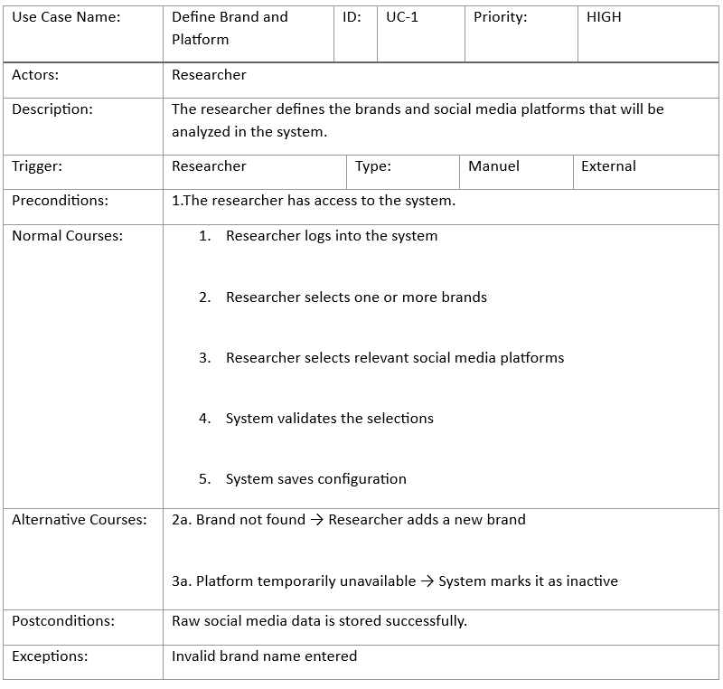
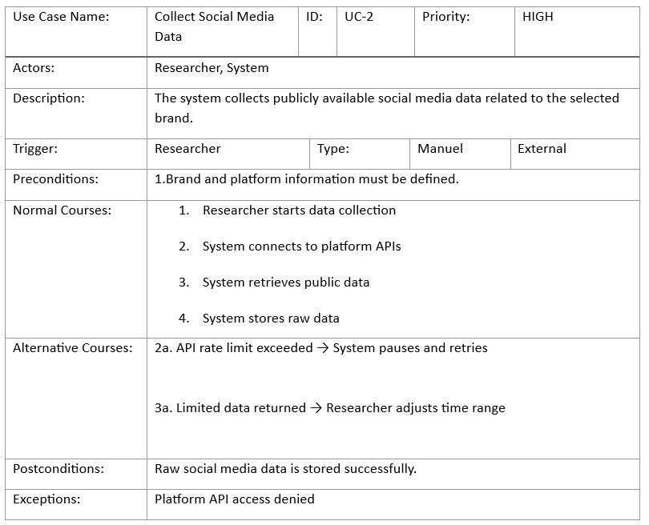
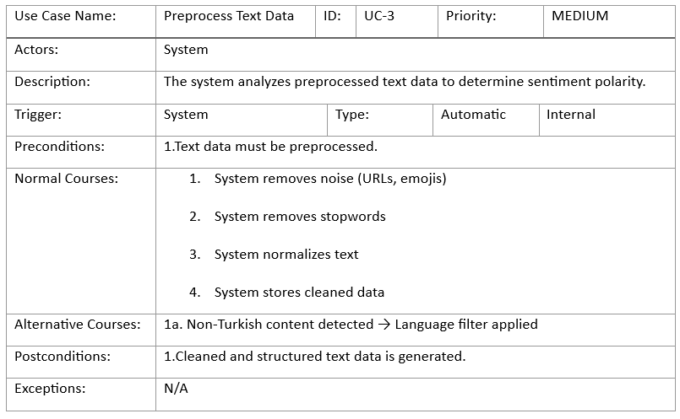
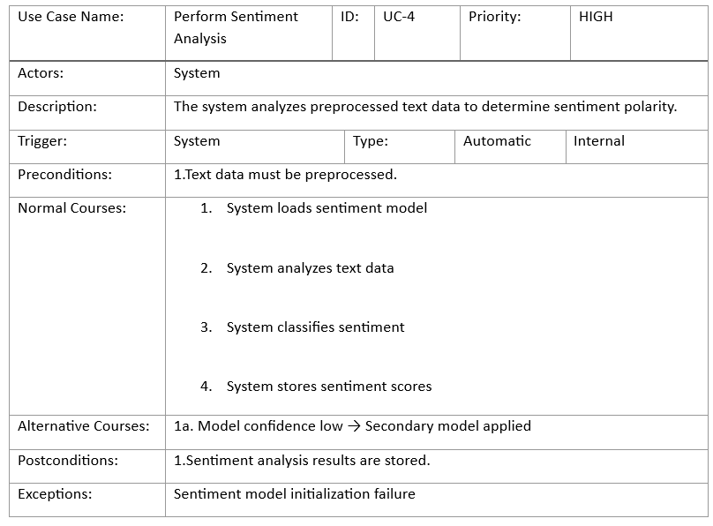
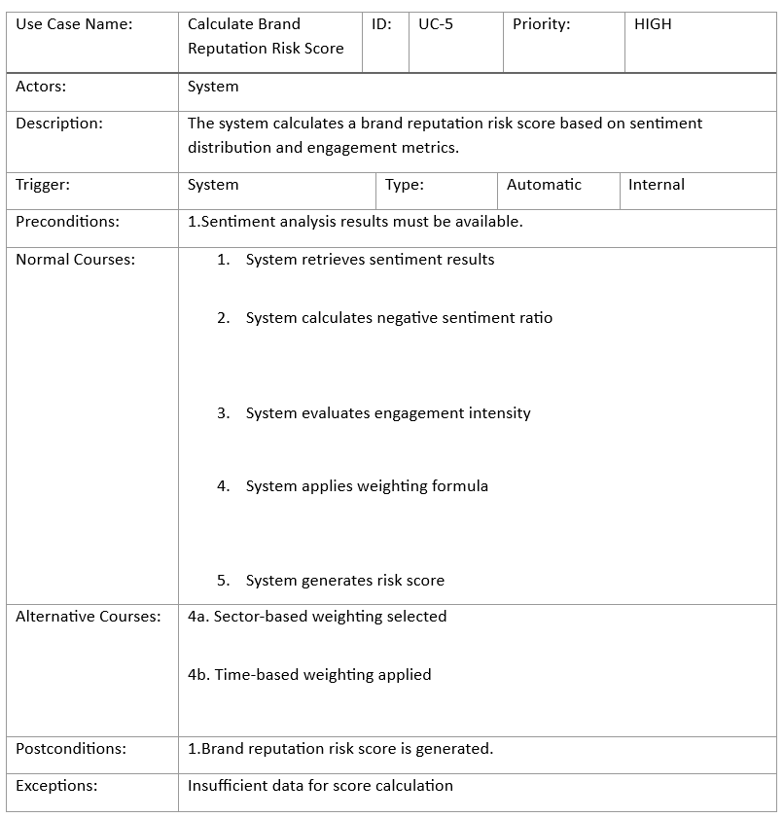
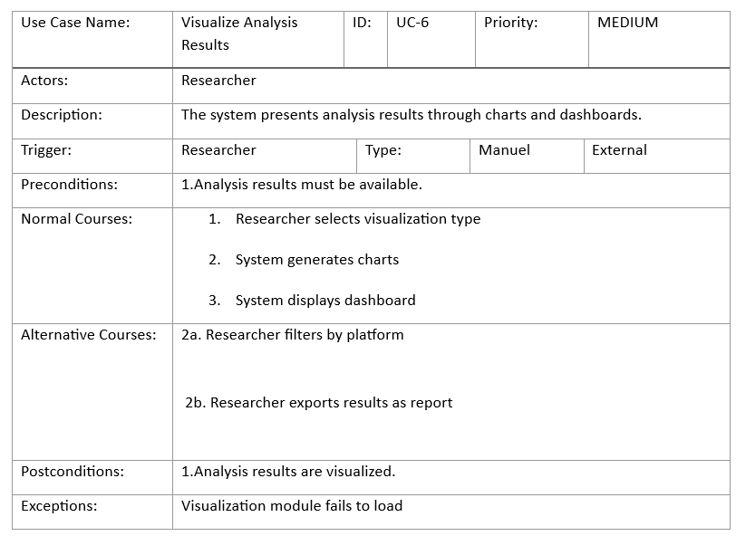
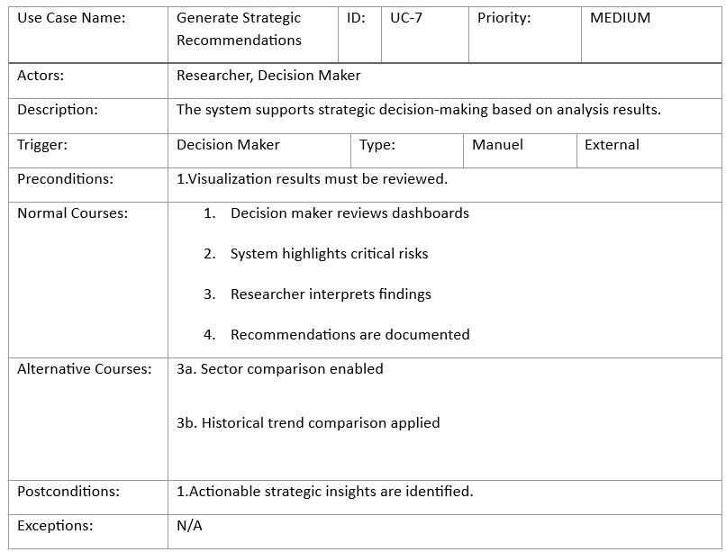
11.2. System Architecture Diagram
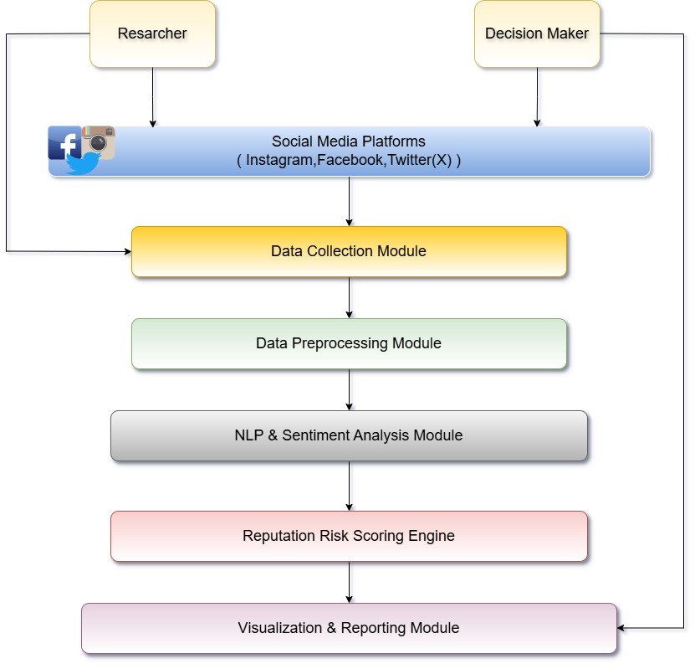
11.3. Diagrams
11.3.1.Context Diagram
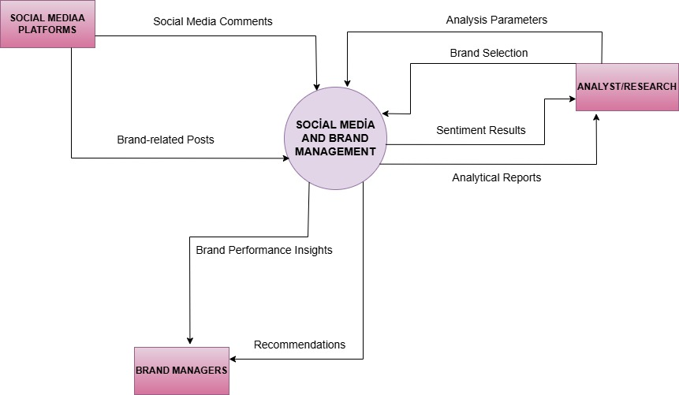
11.3.2. Logical Data Flow Diagram – Level 0
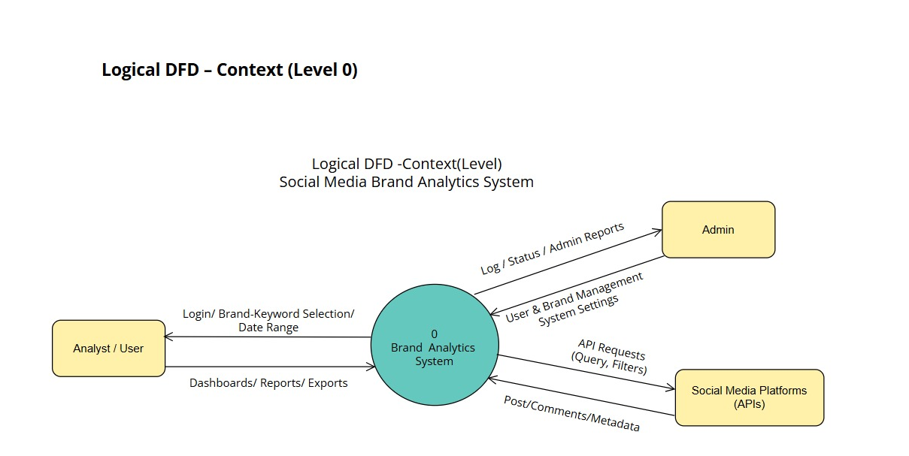
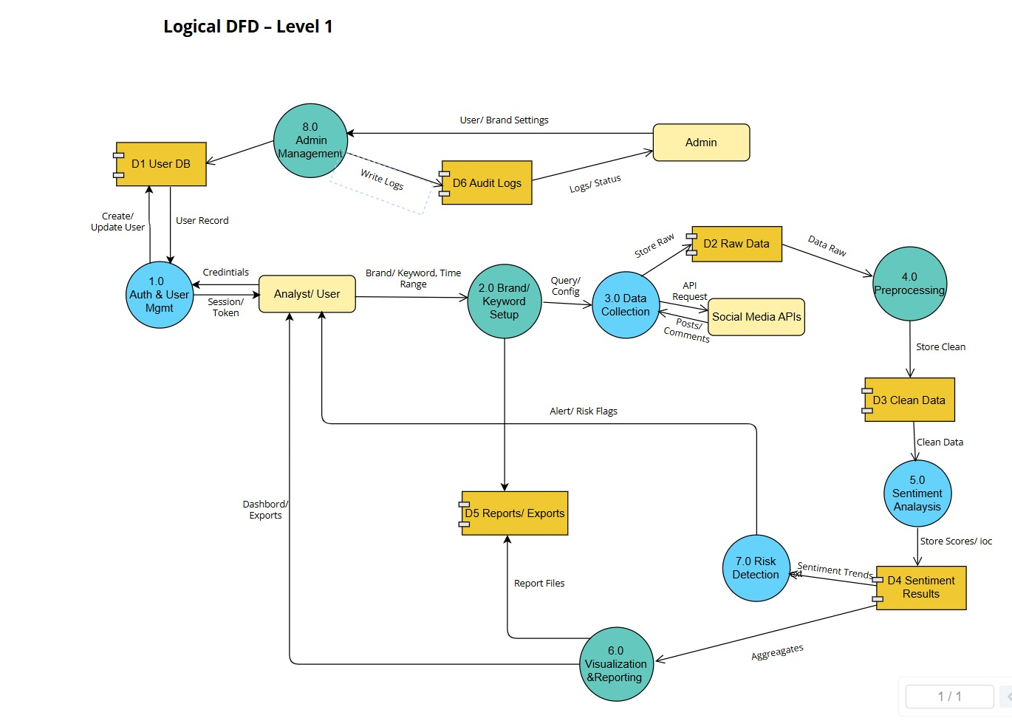
11.3.4. Logical Data Flow Diagram – Level 1

11.3.5. Logical Data Flow Diagram – Level 2
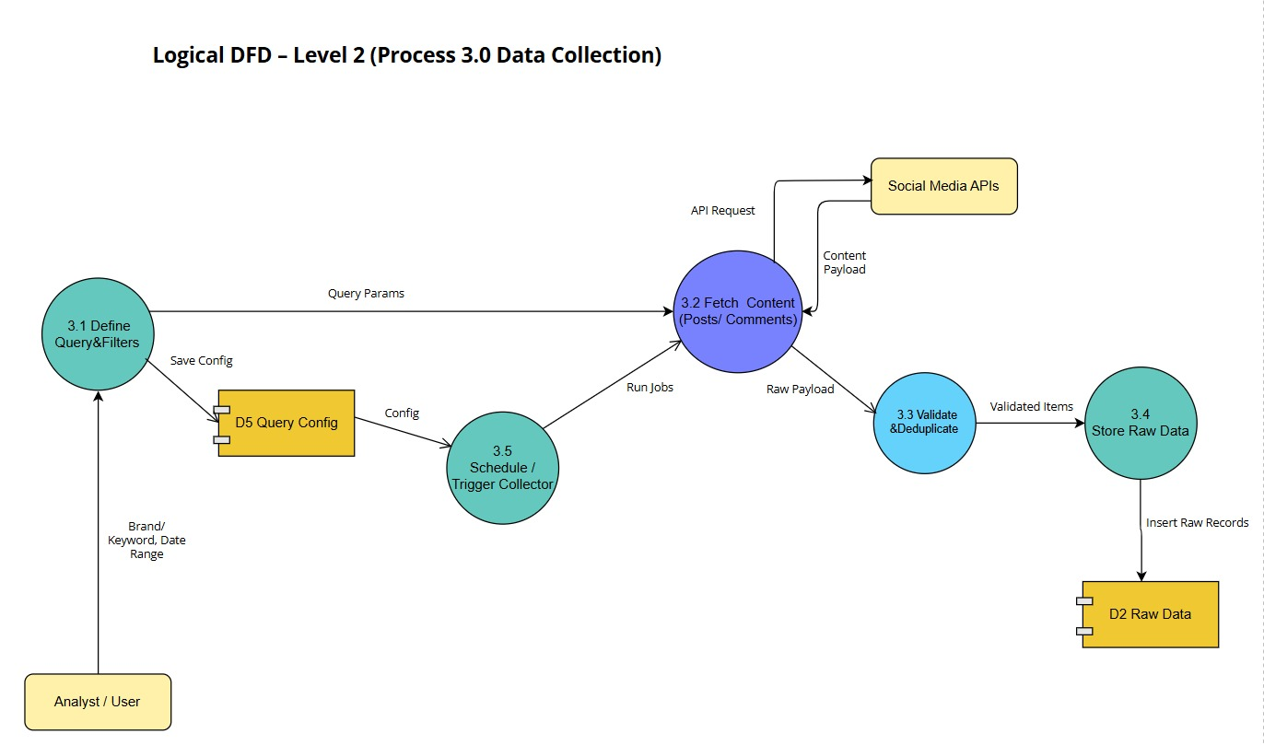
11.3.6. Logical Data Flow Diagram – Level 3
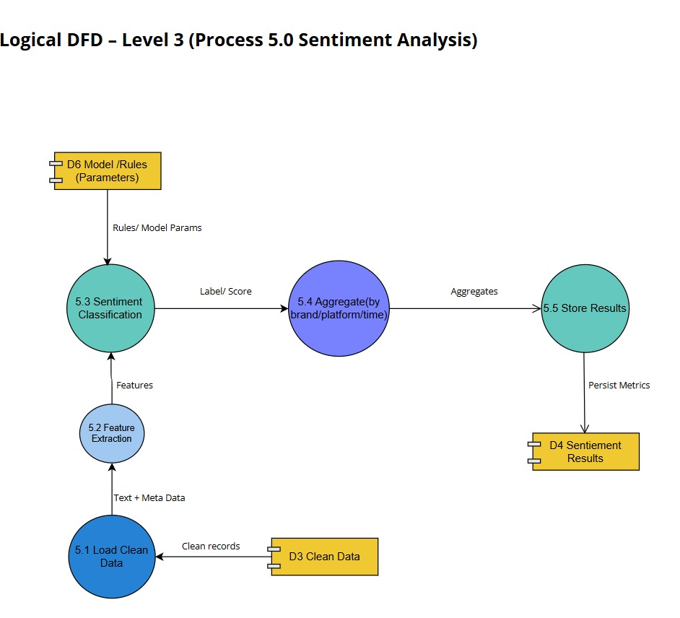

11.3.7. Physical Data Flow Diagram – Level 0

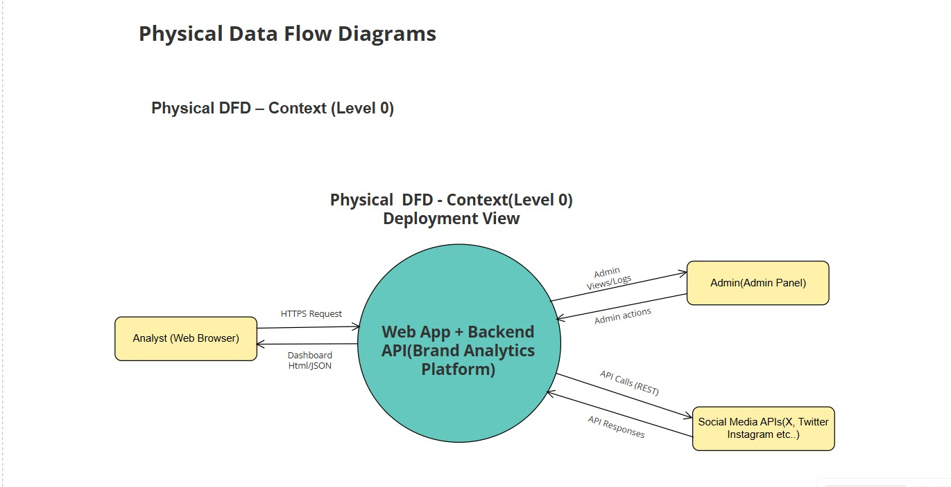

11.3.8. Physical Data Flow Diagram – Level 1

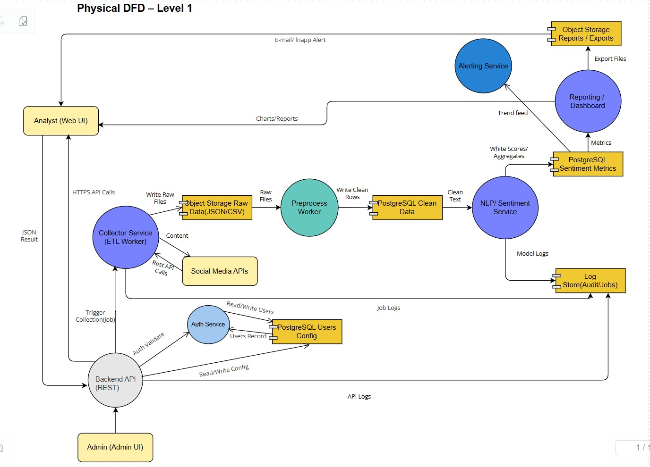

11.3.9. Physical Data Flow Diagram – Level 2

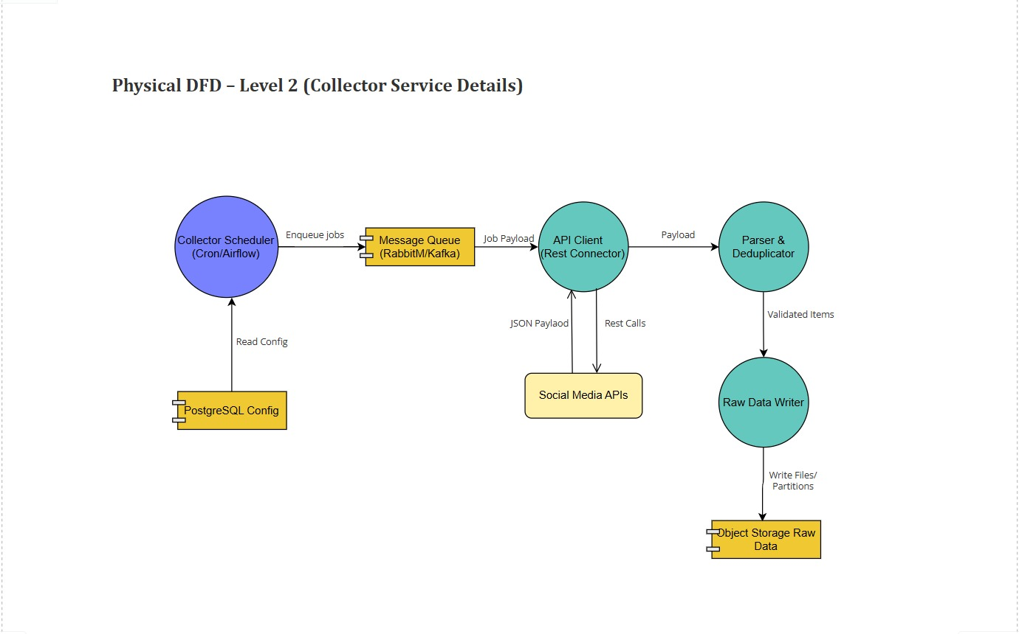

11.3.10. Physical Data Flow Diagram – Level 3

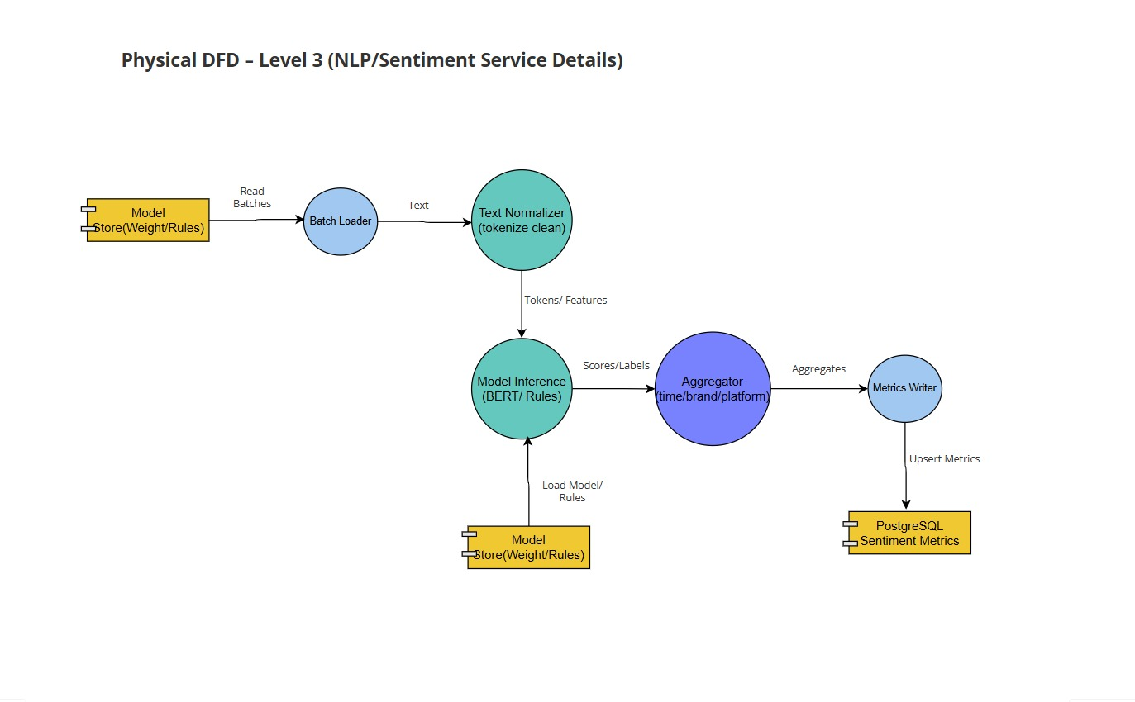

11.3.11. Entity Relationship Diagram

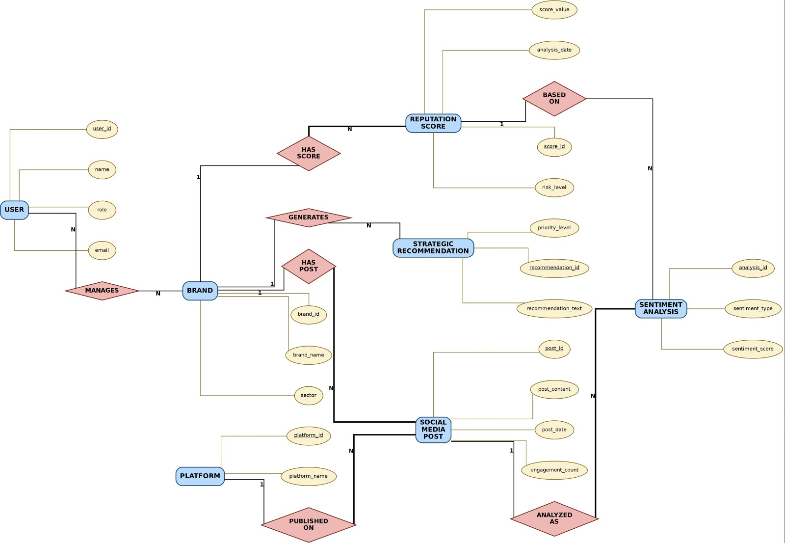

12. CONCLUSION AND RECOMMENDATIONS

12.1 Conclusion of the Project
This senior project focused on social media and brand analysis by using sentiment analysis techniques. The main purpose of the project was to analyze customer opinions shared on social media platforms and evaluate brand perception.
Five major brands from different sectors were selected for the study: Trendyol, Hepsiburada, Garanti Bankası, Turkish Airlines, and Turkcell. These brands were chosen because they actively use social media and have a large customer base. The diversity of sectors allowed a comparative brand analysis.
The project proposed a Social Media Brand Analytics System that collects, processes, and analyzes social media data. The system uses sentiment analysis to classify customer comments as positive, neutral, or negative. This approach helps transform unstructured text data into meaningful and understandable results.
The findings showed that social media sentiment analysis provides valuable insights into customer behavior and brand perception. Brand-based, platform-based, and time-based analyses demonstrated how customer opinions vary across brands and platforms.
Overall, the project achieved its main objectives and demonstrated how social media data can be used effectively for brand analysis and reputation management.

12.2 Evaluation of the Project Objectives
The project objectives defined at the beginning were successfully addressed. The system was designed to analyze social media data and provide meaningful outputs for brand evaluation.
Customer opinions were classified into sentiment categories, allowing clear interpretation of results. Brand comparison helped identify relative strengths and weaknesses across different sectors.
The project also demonstrated how analytical systems can support managerial decision-making. By monitoring sentiment trends, managers can detect potential reputation risks and take early action.

12.3 Managerial Implications
The results of this project have important implications for brand managers. Social media sentiment analysis helps managers understand customer expectations and dissatisfaction points.
Managers can use sentiment results to improve customer communication strategies. For example, repeated negative comments about delivery or service quality indicate areas that need improvement.
Positive customer feedback highlights strengths that can be emphasized in marketing and branding activities. By using social media analysis, managers can make data-driven decisions and improve brand performance.

12.4 Recommendations for Brands
Based on the findings of this project, several recommendations can be made for brands:
- Brands should monitor social media platforms regularly
- Negative customer comments should be detected early
- Customer complaints should be addressed quickly and transparently
- Sentiment analysis tools should be integrated into brand management processes
- Platform-based analysis should be used to improve communication strategies
These recommendations can help brands strengthen their reputation and customer relationships.

12.5 Limitations of the Project
This project has some limitations that should be considered. The data used in the analysis was created for academic demonstration purposes and does not represent real-time data.
In addition, sentiment analysis was limited to three categories: positive, neutral, and negative. More advanced sentiment models could provide deeper insights.
Despite these limitations, the project successfully demonstrated the analytical approach and system design for social media brand analysis.

12.6 Suggestions for Future Studies
Future studies can expand this project in several important ways. While this project focuses on representative social media data, future research can improve analysis accuracy by using real-time social media data. Real-time data allows brands to monitor customer sentiment continuously and respond more quickly to changes in public opinion.
Another important improvement area is the use of more advanced sentiment analysis techniques. In addition to basic positive, neutral, and negative classification, future studies can apply emotion detection methods. Emotion detection can identify specific emotions such as happiness, anger, frustration, or trust. This provides deeper insight into customer feelings and behavior.
Future research can also include additional brands from different sectors. Expanding the number of brands increases the generalizability of results and allows broader comparison. Including international brands can further strengthen comparative analysis.
In addition, future studies can analyze more social media platforms. Platforms such as TikTok, YouTube, and online forums can provide valuable customer opinions. Each platform has unique user behavior, and including more platforms creates a more comprehensive analysis.
Integration of machine learning models is another important direction for future research. Machine learning-based sentiment analysis can improve classification accuracy and handle large datasets more efficiently. These models can learn from new data and adapt over time.
Future improvements can also focus on system automation. Automating data collection, processing, and analysis allows faster and more efficient analysis. This makes the system more practical for real-world applications.
Furthermore, future studies can strengthen the sustainability aspect of the system. By supporting long-term monitoring and responsible brand management, the system can contribute to sustainable business practices.
In conclusion, future research and improvements can significantly enhance the power and practicality of the system. These developments can make social media brand analysis more accurate, scalable, and valuable for both academic and managerial use.

12.7 Final Remarks
In conclusion, this senior project clearly demonstrates the importance of social media analysis for effective brand management in the digital age. Social media platforms have become key communication channels where customers actively share their opinions, experiences, and expectations. For this reason, analyzing social media data is essential for understanding brand perception.
By combining system design, sentiment analysis, and graphical interpretation, the project provides a comprehensive and structured approach to brand evaluation. The system design ensures that data is collected, processed, and analyzed in a clear and organized manner. Sentiment analysis helps transform unstructured social media comments into meaningful insights. Graphical interpretation makes these insights easy to understand and use.
The project shows how information systems can support managerial decision-making. By identifying positive and negative customer sentiment, brands can improve communication strategies, address problems more effectively, and strengthen customer relationships. This contributes to better reputation management and long-term brand value.
From an academic perspective, the project contributes to the literature on social media analytics and brand management. It demonstrates how analytical methods can be applied in business and management studies in a simple and understandable way. The structured methodology supports academic reliability and transparency.
From a practical perspective, the project shows how theoretical concepts can be applied to real-world business problems. The system designed in this project can be adapted by companies to monitor customer sentiment and improve service quality. This practical applicability increases the value of the study.
In addition, the project supports sustainability and ethical considerations by promoting responsible data usage and long-term brand improvement. Aligning with sustainable business practices increases customer trust and supports stable growth.
Overall, this senior project successfully combines academic research and practical application. It provides a strong foundation for future studies and demonstrates the value of social media analysis as a powerful tool for brand evaluation and management.

13. REFERENCES
- Ashley, C., & Tuten, T. (2015). Creative strategies in social media marketing: An exploratory study of branded social content and consumer engagement. Psychology & Marketing, 32(1), 15–27. https://doi.org/10.1002/mar.20761
- Barger, V., Peltier, J. W., & Schultz, D. E. (2016). Social media and consumer engagement: A review and research agenda. Journal of Research in Interactive Marketing, 10(4), 268–287. https://doi.org/10.1108/JRIM-06-2016-0065
- Bilgin, Y. (2018). The effect of social media marketing activities on brand awareness, brand image and brand loyalty. Business & Management Studies: An International Journal, 6(1), 128–148. https://doi.org/10.15295/bmij.v6i1.229
- Bollen, J., Mao, H., & Zeng, X. (2011). Twitter mood predicts the stock market. Journal of Computational Science, 2(1), 1–8. https://doi.org/10.1016/j.jocs.2010.12.007
- Cambria, E., Schuller, B., Xia, Y., & Havasi, C. (2013). New avenues in opinion mining and sentiment analysis. IEEE Intelligent Systems, 28(2), 15–21. https://doi.org/10.1109/MIS.2013.30
- Chae, B. K. (2015). Insights from hashtag #supplychain and Twitter analytics: Considering Twitter and Twitter data for supply chain practice and research. International Journal of Production Economics, 165, 247–259. https://doi.org/10.1016/j.ijpe.2014.12.037
- Dessart, L., Veloutsou, C., & Morgan-Thomas, A. (2015). Consumer engagement in online brand communities: A social media perspective. Journal of Product & Brand Management, 24(1), 28–42. https://doi.org/10.1108/JPBM-06-2014-0635
- Grewal, D., Hulland, J., Kopalle, P. K., & Karahanna, E. (2020). The future of technology and marketing: A multidisciplinary perspective. Journal of the Academy of Marketing Science, 48(1), 1–8. https://doi.org/10.1007/s11747-019-00711-4
- He, W., Zha, S., & Li, L. (2013). Social media competitive analysis and text mining: A case study in the pizza industry. International Journal of Information Management, 33(3), 464–472. https://doi.org/10.1016/j.ijinfomgt.2013.01.001
- Hennig-Thurau, T., Hofacker, C. F., & Bloching, B. (2013). Marketing the pinball way: Understanding how social media change the generation of value for consumers and companies. Journal of Interactive Marketing, 27(4), 237–241. https://doi.org/10.1016/j.intmar.2013.09.005
- Kaplan, A. M., & Haenlein, M. (2010). Users of the world, unite! The challenges and opportunities of social media. Business Horizons, 53(1), 59–68. https://doi.org/10.1016/j.bushor.2009.09.003
- Kietzmann, J. H., Hermkens, K., McCarthy, I. P., & Silvestre, B. S. (2011). Social media? Get serious! Understanding the functional building blocks of social media. Business Horizons, 54(3), 241–251. https://doi.org/10.1016/j.bushor.2011.01.005
- Kotler, P., Kartajaya, H., & Setiawan, I. (2021). Marketing 5.0: Technology for humanity. Wiley.
- Liu, B. (2012). Sentiment analysis and opinion mining. Morgan & Claypool Publishers.
- Mangold, W. G., & Faulds, D. J. (2009). Social media: The new hybrid element of the promotion mix. Business Horizons, 52(4), 357–365. https://doi.org/10.1016/j.bushor.2009.03.002
- Statista. (2024). Social media usage worldwide. Statista Research Department.
- Tuten, T. L., & Solomon, M. R. (2020). Social media marketing (3rd ed.). Sage Publications.
- United Nations. (2015). Transforming our world: The 2030 agenda for sustainable development. United Nations.
- United Nations. (2023). Sustainable Development Goals: Goal 8 and Goal 12. United Nations Development Programme.
- Vries, L. de, Gensler, S., & Leeflang, P. S. H. (2012). Popularity of brand posts on brand fan pages. Journal of Interactive Marketing, 26(2), 83–91. https://doi.org/10.1016/j.intmar.2012.01.003
- Zhang, L., Ghosh, R., Dekhil, M., Hsu, M., & Liu, B. (2011). Combining lexicon-based and learning-based methods for Twitter sentiment analysis. HP Laboratories Technical Report.
- Aaker, D. A. (2014). Marka Değeri Yönetimi. Mediacat Yayınları.
- Kotler, P., Kartajaya, H., & Setiawan, I. (2018). Pazarlama 4.0. Optimist Yayınları.
- Erdem, T., & Swait, J. (2004). Marka Güveni ve Tüketici Davranışı Üzerine Bir İnceleme.
- Kaplan, A. M., & Haenlein, M. (2010). Users of the world, unite!
- Kara, T., & Coşkun, A. (2012). Sosyal Medyanın Tüketici Davranışları Üzerine Etkisi.
- Yıldırım, A., & Şimşek, H. (2016). Sosyal Bilimlerde Nitel Araştırma Yöntemleri. Seçkin Yayıncılık.
- Çetin, G., & Eryiğit, G. (2018). Türkçe Metinlerde Duygu Analizi Üzerine Bir Çalışma.
- Akın, A. A., & Akın, M. D. (2007). Zemberek: Türkçe Doğal Dil İşleme Kütüphanesi.
- OpenAI. (2024). ChatGPT (GPT-4) [Large language model]. https://chat.openai.com/

